“The Perfect Retail Transaction”

☺ and greet the customer!

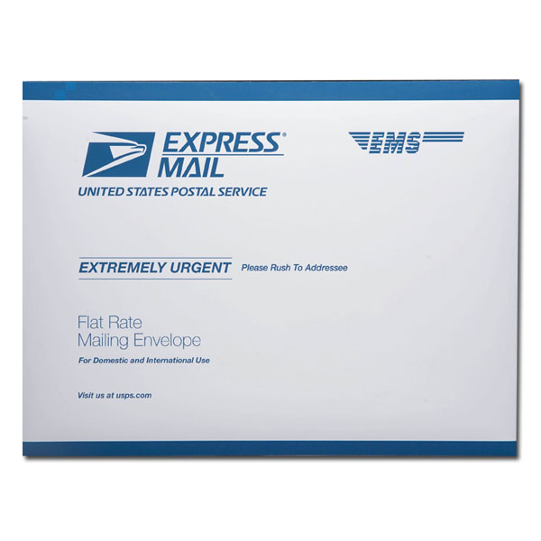
Does this package contain anything Liquid, Fragile, Perishable, or Potentially Hazardous?”

Would you like to send this Express Mail, a guaranteed service which includes $100 worth of insurance?
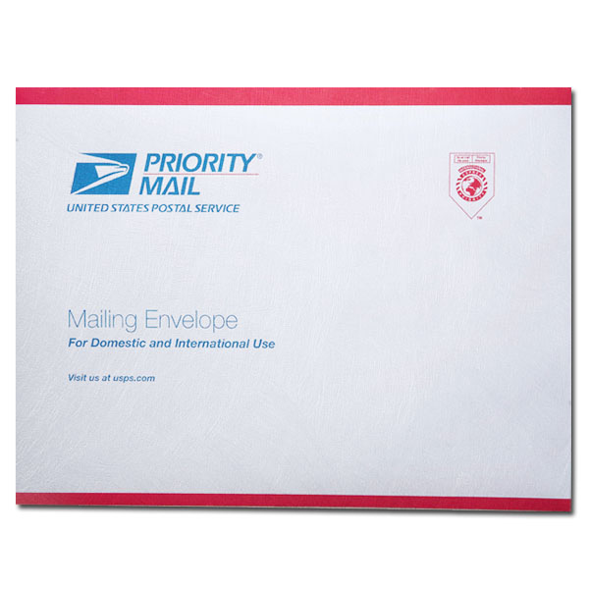

Would you like to send this Priority Mail a 2 to 3 day service?
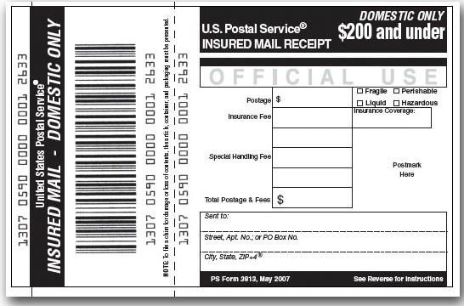

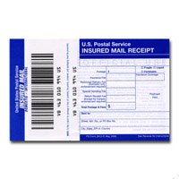
Do you need Insurance for protection against loss or damage?

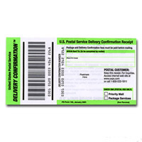
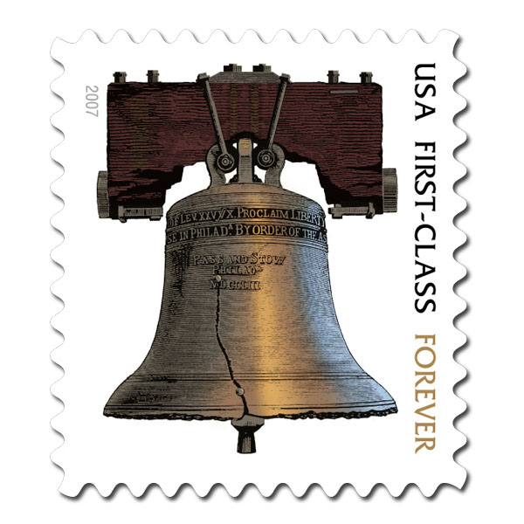
Will you need Delivery Confirmation to confirm delivery of your package?

Do you need any STAMPS today?
Thank the customer for their business & hand them their receipt.

