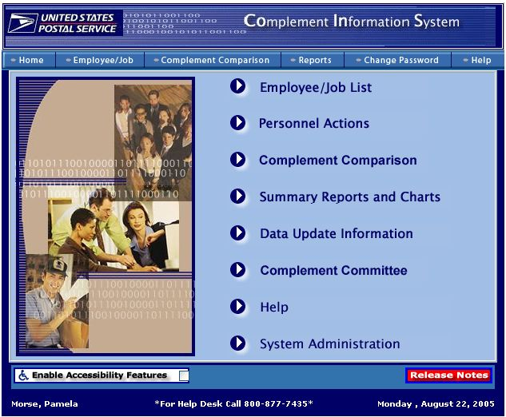
New!

- Click on Complement Comparison from the home page menu. This will bring you to the main Complement Comparison page. This is the starting point for viewing Earned, Authorized, and On-Rolls Complement.

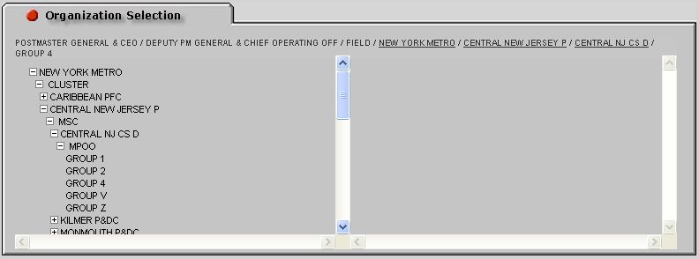

- Go to the organization selection tab at the left side of the page. To select an organization, click on the + symbol to expand the menu. The amount of information you can view depends on your level of access to the system.

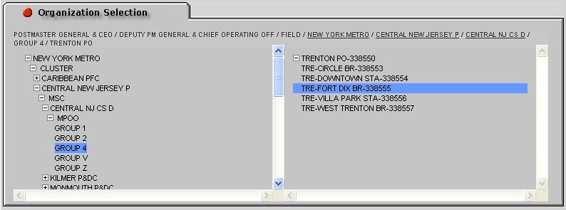

- Choose the area, cluster, bid cluster, MSC, or MPOO you’d like to see information for. When you click on it, it will appear in the right column. Now you are ready to choose how you would like the information to be displayed by using the Display Options menu.
After selecting an organization, scroll to the middle of the page to choose how you would like the data displayed. You may display by function or by organization.

Display by Function

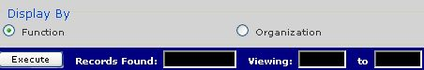

- To display by function, select the radio button next to Function.

- Click the Execute button to see the information you requested.

Display by Organization

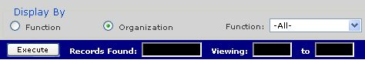

- To display by organization, select the radio button next to Organization.

- A Function drop down box will be displayed.
New!
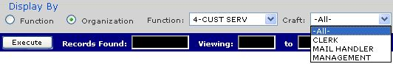

- Choose the function that you’d like displayed.

- Choosing 1-MAIL PROC or 4-CUST SERV will display a Craft drop down box with the clerk, mail handler, management or -all- choices. Please Note: the management choice is a new detail that can be displayed.

- Click the Execute button to see the information requested.
After clicking the Execute button to see the information requested, you will have the option to choose the columns you would like to see and the order of the columns.

Default View

- The Default view will be displayed.

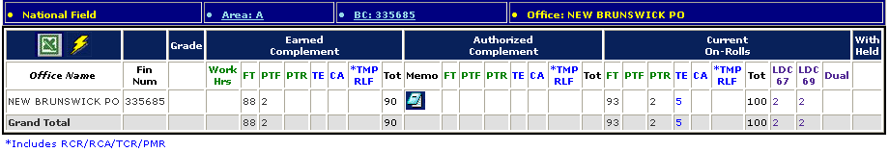

- The default column view shows the Earned Complement, Authorized Complement, and Current On-Rolls.

Post Impact View

- To see the Post Impact view, choose the radio button next to Post Impact.

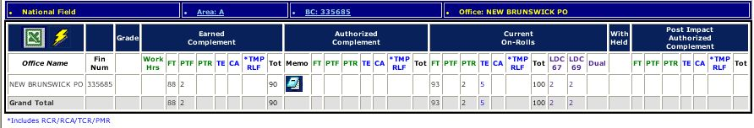

2. The Post Impact Authorized Complement columns appear on the far right.

Management Less Temp/Relief View

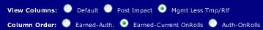

- To see the Management Less Temp/Relief view, choose the radio button next to Mgmt Less Temp/Rlf. The information displayed is driven by SAP OM non-bargaining authorized positions. The Management Less Temp/Relief and Total columns appear on the far right.
New!


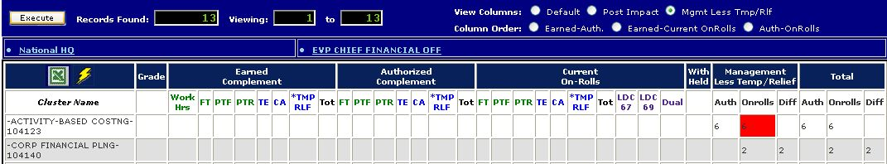
Once the information is displayed, you will be able to drilldown to additional levels of detail, including finance number, office detail, and memos.

View Office Information

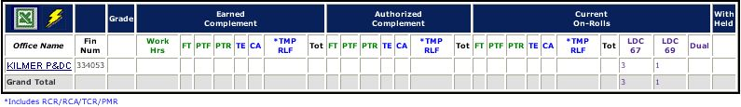

Click office names that are hyperlinked to drilldown to the Unit level.

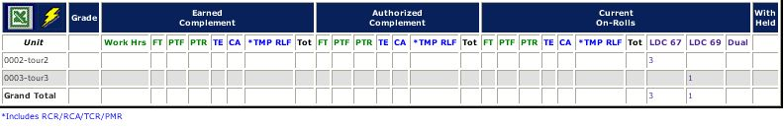

- The screen now displays information at the Unit level.

Display Acronyms

- FT – Full Time
- FTF – Full Time Flexible
- TMP/RLF – Temporary Relief
- UAR – Unassigned Regular
- PTF – Part Time Flexible
- PTR – Part Time Regular
- TE – Transitional Employee
- CA – Casual
- LDC – Labor Distribution Code

View Finance Number Office Details

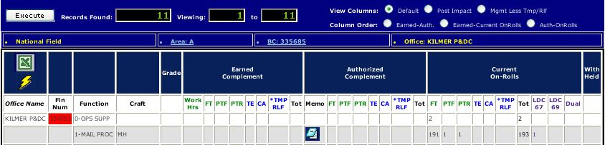

- Mouse over the finance number next to the office name on the report. Double click the highlighted cell to see finance number information. A pop-up box will appear with information about that location.

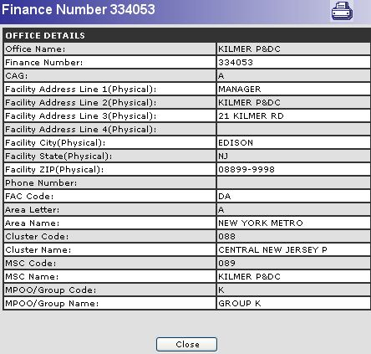

To print the information in the pop-up box, click the printer icon in the top right-hand corner.

- Click Close to close the pop-up box.

View an Authorized Complement Memo

Click on the memo icon under the function that you’d like to see. A pop-up box will appear with a listing of all available memos.

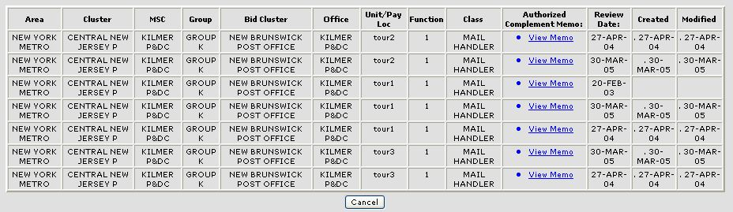

Click View Memo to see the memo text.

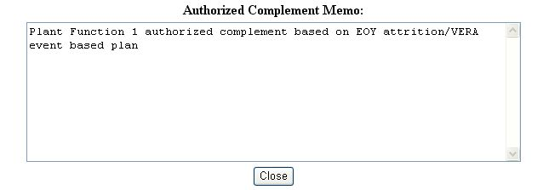

- A box will be displayed with the memo text. Click Close to close the pop-up box.

Use the same process to view Post Impact, Grade, and Earned Complement memos.

Exporting to Excel

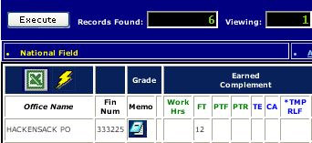

- Click the Excel icon in the top left corner to download an excel spreadsheet containing the information displayed. A File Download pop-up box will appear. Please Note: the lightning icon next to the Excel icon will link to the eFlash System.

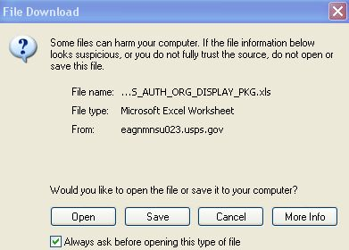

- Click Open to view the spreadsheet or click Save to save the spreadsheet to your computer.

- When saving your exported file, remember to save it to a location you’ll remember and to save it as an Excel spreadsheet.
View Complement Data

The level of information displayed is dependent on the level of access you have. Below are examples of the Field-related bargaining view and the HQ-related bargaining view.

- After selecting the Organization Level you’d like displayed, click the Execute button to see the information requested. Click on any hyperlinked (underlined) organization to drill that organization down to a finer level of detail.

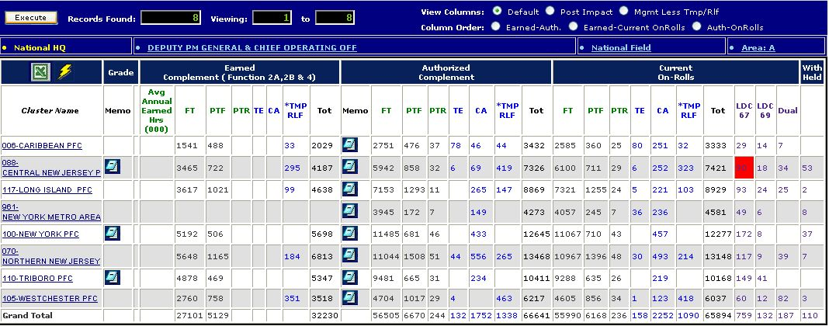
New!
a. Field-Related Bargaining View

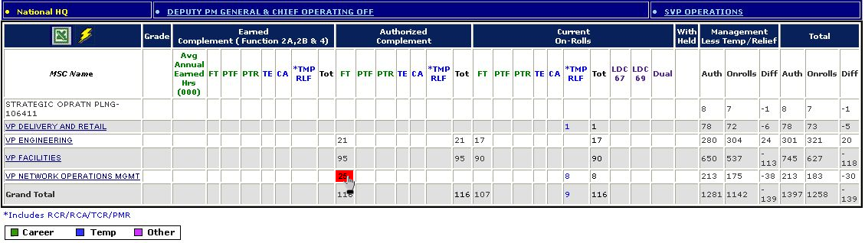
b. HQ-Related Bargaining View

- Mouse over any number in the columns of the report. If the cell turn red, click the red highlighted cell to see information. A pop-up box will appear displaying the complement records represented by the highlighted number.
  - IAll Currrent On-Rolls and Management Less Temp/Relief cells will turn red and display additional information when clicked on.
  - For HQ and HQ-Related organizations, the Authorized Complement column cells will also allow the user to drill-down to the complement records represented by the number in the cell.

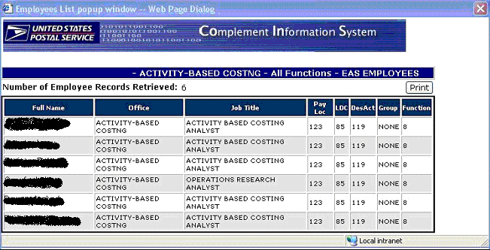

To print the information in the pop-up box, click Print in the top right-hand corner.
- Close the window by clicking the X in the top right-hand corner.

Print Complement Pop-up Data

- Cells that have employee details will turn red when moused over. Click on any cell that turns red and a window will appear with a list of the on-rolls employees represented by that cell.

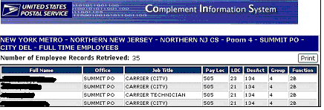

- Click Print. A print window will appear.

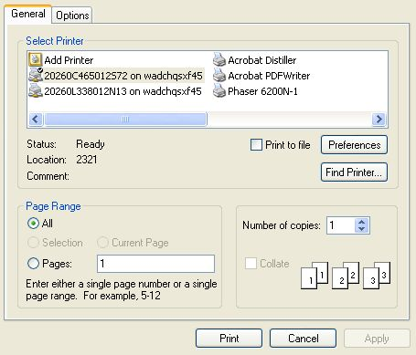

- Click Print to print the records.
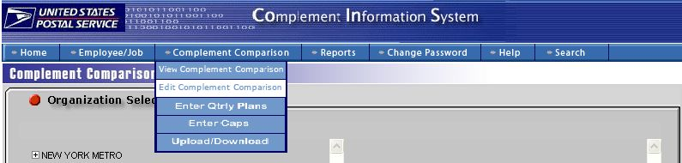

- Mouse over the Complement Comparison tool bar choice at the top of the page and click Edit Complement Comparison.

Selecting an Organization to Edit

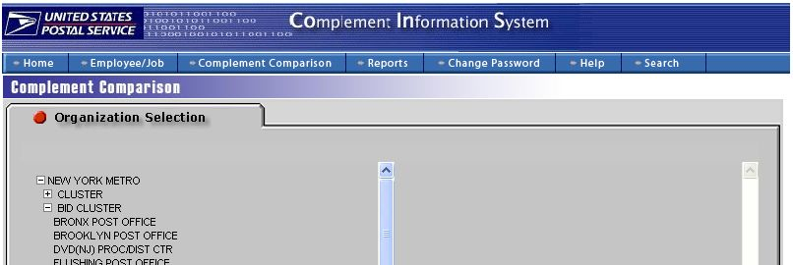

- Go to the organization selection tab at the left side of the page. To select an organization, click on the + symbol to expand the menu. The amount of information you can view depends on your level of access to the system.

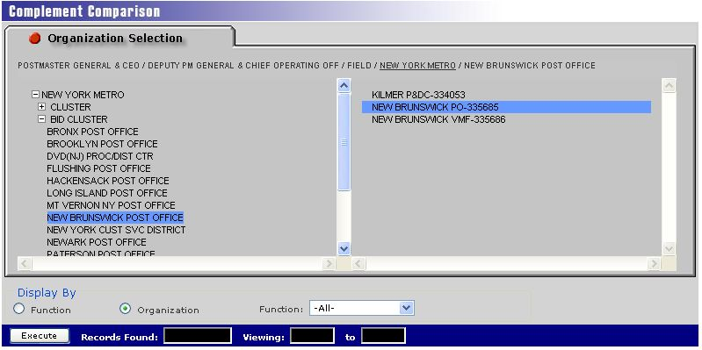

- Choose the area, district, cluster, bid cluster, MSC or MPOO you’d like to see information for. Click on the organization you’d like to edit in the right column. Authorized Complement can only be entered at the lowest level – either finance number or unit. Complement is entered by function.

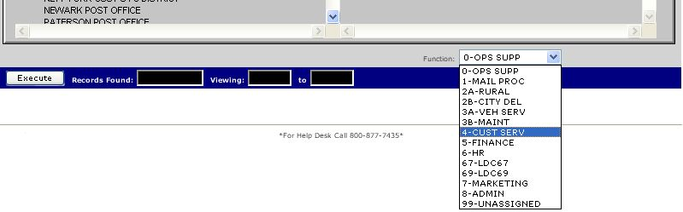

3. Choose a function from the function drop down menu. Click Execute to continue.

4. Drill down to more detailed levels of information by clicking on the hyperlinked names.

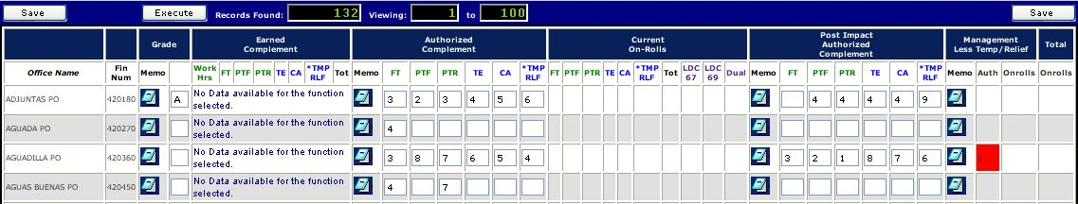

5. You will not be able to edit the information in the Management Less Temp/Relief column, however you may view the information in that column by mousing over the number and clicking the highlighted box. Add or edit the information in the spaces provided and click Save on the top left or right hand sides of the report.

Adding and Editing Memos

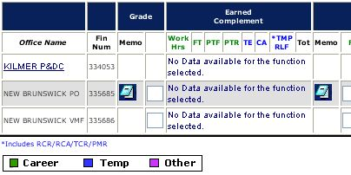

- Click the memo icon to write or edit a new memo.

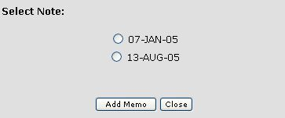

- If this is the first memo to be added to this record, proceed to step 3. If there are already memos attached to this record, you will see a list of memo dates. Use the radio buttons to choose the memo that you would like to edit or click Add Memo to create a new memo.

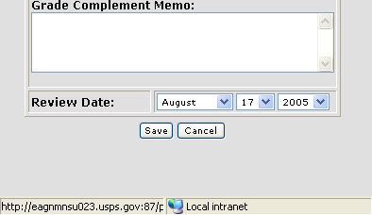

- The memo box will display. Type your comment or add your edit in the box provided. Choose the review date by using the drop down date menu. The date will automatically default to today’s date. Click Save to save your memo. A message telling you that your save has been successful will display.

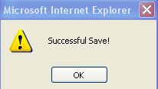

- The above message will display. Click OK to continue.

5. A list of your previous dated notes will display. Click Close to continue.

