Version 1.0
February 2009

Human Resources Shared Services
Combined Field User Guide

Human Resources Shared Services Field User Guide

Introduction
This guide provides a comprehensive reference to the common procedures used in the Human Capital Enterprise System (HCES). It includes step-by-step procedures, appropriate requests, references, and describes processes to accomplish Human Resources (HR) activities between District HR Local Services, Corporate Personnel Management, Field Managers and Human Resources Shared Service Center (HRSSC).

Purpose:
This guide is for those who have a need to conduct Human Resources activities in HCES via the HRSSC. It is noted that the HRSSC acts on instructions from Local Services, Corporate Personnel Management and Field Managers and plays no role as a gatekeeper.

Table of Contents
Organization Management (OM) 5
Introduction 5
Responsibility 5
Position Data 6
Worksheets 6
Position Maintenance 9
RAR-100—Request for Creation of New Bargaining-Unit Positions 9
RAR-200—Authorization to Convert to Full-Time 9
Structure Changes 10
Create and Maintain Organizational Units 10
Add a new cost center 10
Other Organizational Changes 13
Personnel Administration 14
Benefits 14
Communicating the Death of an Employee 15
Retirements 16
Reassignments/Placements resulting in PS Form 50 17
OM-500—Change(s) To Assignments 17
RTR – Retirement, Thrift & RIF (Reduction in Force) 18
Separations 18
Job Bid Management 21
Job Bidding Processes Definitions 22
Posting Schedule Process Steps: 25
Vacancy Determination 27
Vacancy Determination Process Steps: 28
Posting Process 29
Review of Positions and Finalization of Posting 30
Accept Bids Process 31
Bid Processing 32
Bidder Review Process Steps 32
Informational Guidelines 33
Bid Awards 35
Award Bids Process Steps 36

Manual Bidding Process 37
Overview 37
Manual Bidding Process Steps: 37
Vacancy Posting 37
Process and Award Bids 37
Training and Pending Qualifications 38
Information, Questions and Answers 39
PostalPeople Toolkits 40
http://blue.usps.gov/hrisp/hce/toolkits.htm 40
Managers’ Portal (MY WORK) 43
Work with My Employees 44
Employee Information and Resources 44
Reports 44
Upcoming Deadlines 45
Employee Self Service (ESS – MY LIFE) 46
My Profile 46
My Skills 47
Additional Information 47
APPENDICES/ EXHIBITS 48
APPENDIX 1: HCES Organization Management Maintenance Responsibilities 48
APPENDIX 2: Human Capital Enterprise System Terms vs. CMS Terms 49

Organization Management (OM)

Introduction
OM is the module within HCES that makes the US Postal Service organizational structure available to its Human Resources staff. The technology that comprises the Human Capital Enterprise System (HCES) is Systems, Applications, and Products (SAP). HCES replaces CMS (Complement Management and Staffing) and OMSS (Organization Management and Staffing System). OM is the backbone of HCES containing the structure of the USPS . . . every employee, every position, every installation, every district, and every area in the country including Headquarters.

From an individual employee perspective, OM touches every employee regardless of their position or the length of their employment. How? HCES tracks people from the moment they apply to take a postal examination until the day they separate from the USPS. If the information in HCES is not accurately maintained, employees will not be paid correctly and/or their paychecks may be sent to the wrong address.

Positions also change according to operational needs; sometimes when they are vacant and sometimes when they are encumbered. Whether it is where we work (section, work area, finance number or tour), when we work (schedule and off days), how we work (skills/qualifications/licenses), in which positions we work (unassigned, conversion to full-time, reassignments, promotions, changes to lower level, etc.) or if we work at all (excessing, abolishing, separations, retirements, death), change is all around us and the people with whom we work.

When any of this data changes, OM must be updated so that HCES can function correctly and feed accurate information about our employees to other systems. HCES provides reports and electronic notifications through Managers’ Portal to managers and/or supervisors when action is required of them or when actions are taken that affect their workforce. If the data in OM is incorrect, these notifications will go to the wrong supervisor or manager, or an employee may not be paid, and/or data in reports will be incomplete or inaccurate. Please see Appendix 2 for a list comparing some of the most frequently used HCES terms to CMS terms.

Responsibility
You may be asking yourself who is responsible for notification of changes that need to be made in OM? The answer depends on WHAT is being updated: structure/positions, employee personal data, or position data.

USPS Organization Structure and Non-Bargaining Positions
If the organizational structure or the number of non-bargaining positions is changing, OM is updated and maintained by the HRSSC, Area Human Resources staff, and/or Headquarters Organizational Effectiveness (see Appendix 1 for detailed responsibilities).

Employee Personal Data
Changes to employee data happens as life events occur: name changes related to marriage or divorce, address changes as we move our residence; emergency contacts as our relationships change; health benefits coverage when we marry, divorce or have children; and what we do with our postal salaries in Allotments, Annual Leave Exchange, Flexible Spending Accounts and the Thrift Savings Plan.

Since employees are the masters of their own data, only they know when updates are needed. PostalEASE, LiteBlue, and Human Resources Central Kiosks can be used to change personal data in HCES 365 days a year, 7 days a week, 24 hours a day. Employees can change their mailing/residence address, and emergency contact information on LiteBlue, Human Resources Central Kiosks, submit a PS 1216 Change of Address Form to HRSSC or call HRSSC Monday through Friday, 7:00 AM to 8:30 PM EST at 1-877-477-3273 Option 5; TDD/TYY 1-866-260-7507.

Through PostalEASE, employees can perform the following functions:

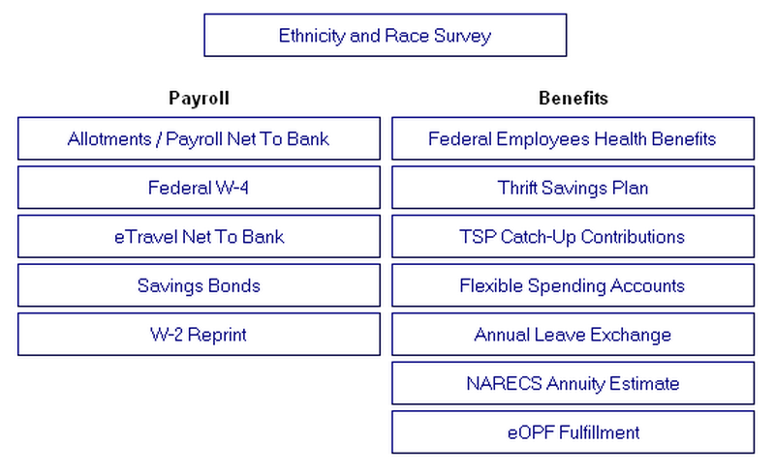
HCES will also give employees access to personal data through Employee Self Service (ESS) based on employee identification number and PIN. Personal information that was traditionally available through Personnel Services Monday through Friday during normal business hours is now available to every employee at any time of the day or night by utilizing PostalEASE or LiteBlue.

Position Data
For changes to positions, Local Services will notify the HRSSC via the appropriate worksheet sent to the OM mailbox for your Area.

Worksheets
In order to standardize communications and to get work from the field managers to HRSSC, personnel processes were redefined and worksheets developed to provide needed information to the HRSSC to process the request. The worksheet contains the data required for work to be done in HCES, explanation of data elements and terminology; and, identity of the local contact person if additional information is needed by the HRSSC to process the request.

The standardized request (worksheet) used depends on whether the position is vacant or occupied and whether the position is involved in the bidding process. The following scenarios will guide you to the appropriate worksheet.

Which Worksheet Should I Use?
Event | Details | Worksheet
RCA/RCR/TRC occupied | Break in service | PA-2300 – Non-Career Separation & Rehire After Required Break in Service
RCA/RCR/TRC reassignment | After break | PA-2300 – Non-Career Separation & Rehire After Required Break in Service
Casual reappointment after break | Non mass reappointment | PA-2300 – Non-Career Separation & Rehire After Required Break in Service
Casual’s second appointment expires in 2 weeks | Need to appoint a new casual | PA-2100: Accession Worksheet,
Hire a PTF Clerk position |  | PA-2100: Accession Worksheet,
Create new EAS position | New EAS position not previously filled | OM-450: EAS Selection & Position Request/Change
Create New Full Time Bargaining unit position | For Posting or recruitment purposes | RAR-100: Request for Creation of New Positions
Hire 2 new casual | After following local procedures for authorization of casual appointments | PA-2100: Accession Worksheet,
Out of compliance with Article 7.3 re full-time employee ratio for your installation | Need to convert 5 PTF mail handlers to Full-Time | RAR200: Authorization to Convert to Full-Time
Worked a PTF clerk in the same assignment 8 hours within 10 on the same five days each week over a 6-month period | This office has 200 or more man years of employment in the regular workforce (APWU national agreement, 7.3.C) | RAR-200: Authorization to Convert to Full-Time
Need to abolish an occupied bargaining-unit position | Written employee notification provided at the local level | JB-1300: Management of Occupied Positions
Consolidation of plant operations | Excessing 40 mail handlers out of plant. In-Plant Support will submit event documentation to Complement Committee. If approved, Complement Committee will submit to Area for approval. If approved, union notifications will be made. | OM-600: Request to Update HCES
Moving casual from tour 2 to tour 1 | Pay location changes | OM-400—Position Change Request Update pay locations in TACS
Moving PTF from Tour 2 to Tour 1 | Not changing cost center | OM400—Position Change Request Update pay location in TACS
Changing LDC on position | LDC changes cannot be made in HCES | Update LDC changes in TACS
Changing employee’s schedule by 15 minutes | Does not require reposting | OM--400—Position Change Request  or through Position Change Request in Managers’ Portal
Adding valid drivers license to a position |  | OM-400—Position Change Request, Block 15, enter “Valid Drivers License” or through Position Change Request in Managers’ Portal
Modified position created for rehabilitated employee | Position no longer  needed once vacated by rehabilitated employee | OM-400—Position Change Request, Block 14, enter Incumbent Only or through Position Change Request in Managers’ Portal
Moving all casuals to a centralized pay location | No change in cost center | OM-400—Position Change Request, Block 13, enter name of new section or work area or through Position Change Request in Managers’ Portal; change pay location in TACS
RCA/RCR/TRC assignments | Change to assignment | OM-500—Change(s) to Assignment
Moving ASP from one post office to another | Changing cost center | OM-500—Change(s) To Assignment
Move PTF employee from one station to another | Changing cost centers | OM-500—Change(s) To Assignment
Moving casual employee to a new cost center | Changing cost center | If in accordance with DAS award and consistent with original triggering event, use OM-500—Change(s) To Assignment
Change reporting relationship of a post office to a different Manager/Post Office Operations |  | OM-600—Request to Update HCES
Change reporting relationship of a station to a different Manager/Customer Service Operations |  | OM-600—Request to Update Organizational Structure
Eliminate an operation on Tour 1 and establish it on Tour 2; e.g., moving CFS from Tour 1 to Tour 2 operation |  | OM-600—Request to Update Organizational Structure
Move carrier routes/delivery zone from one station to another |  | OM-600—Request to Update Organizational Structure
Change name of installation |  | OM-600—Request to Update Organizational Structure
FT carrier retired creating a vacancy | Job bidding is automated | Classical Vacancy Report and JB-1000: Automated Posting Vacancy Coversheet
Need to revert a position | Make all contractually required union notification at the local level, inviting union feedback where appropriate, and make final written decision notification. | Annotate Vacancy Report “revert”, if between posting cycles or in the manually posting BC’s use JB-1200—Request to Process Manual Bidding Results.
Live Bidder | Employees submit to District LS | JB-1100: Live Bid Request
FT carrier retired creating a vacancy | Job bidding is NOT automated, position posted locally | JB-1200—Request to Process Manual Bidding Results
Changing employee’s schedule by more than 4 hours | Requires Reposting (review LMOU) | JB-1300—Bid Management of Occupied Position
FT employee on 204-B detail in excess of 4 months | Automated Bidding | JB-1300—Bid Management of Occupied Position
Changing begin time on schedule to 1 hour earlier | Requires Reposting | JB-1300—Bid Management of Occupied Position
Abolish bargaining–unit positions |  | JB-1300: Management of Occupied Positions
Changing the days off on a Part-Time Regular position | Requires Reposting | JB-1300:Bid Management of Occupied Position

Position Maintenance

Create New Positions

RAR-100—Request for Creation of New Bargaining-Unit Positions
This worksheet is used for the creation of new career bargaining-unit positions which will be posted for bid or offered through recruitment (eCareer). Current District practices must be followed for authorizations prior to submission to the HRSSC for processing. The RAR 100 does not have to be sent to the HRSSC for creation and filling of non-career. These positions are created at the time accession information is submitted to the HRSSC. To create new EAS positions the OM-450 is used.

The RAR-100 can be found on the PostalPeople website under “worksheets” or in the Organization Management “Toolkit” on the web.

Conversion to Full-time

RAR-200—Authorization to Convert to Full-Time
Field managers must follow current District/Area instructions for processing requests to convert to Full-Time. Submit these requests once local instructions have been followed and a resulting action needs to be taken by the HRSSC.

This worksheet is for use when an installation is out of compliance with the ratio of Full-Time employees as required by Article 7.3 of the APWU, NALC and Mail Handlers National Agreements.

This request identifies where it was initiated and who authorized it at the local level, and then identifies the craft being converted, the number of positions to be converted and the reason for conversion (maximization or craft ratio compliance). The remainder of the request is designed to accommodate multiple entries and consists of three sections. The first section identifies an employee that is being converted to an unassigned regular position. (The electronic version has a drop-down table available for selection). The second section is completed if a residual position will be used to assign the newly converted Full-Time employee. The third section provides the HRSSC with position information if a new position is being created for assignment after conversion.

The RAR-200 is completed locally in Excel format and can be attached to an email message and sent to “HRSSC RAR200/JB1200 (Area name)”. This worksheet request can be found on the PostalPeople website under “worksheets” or in the Organization Management “Toolkit” on the web.

The worksheets for creation of new positions RAR-100 and conversion to full-time RAR-200 are called Resource Allocation Requests (RAR) because they involve complement decisions by the District Complement Committee. The RAR-100 and RAR-200 require that a District Complement Committee (DCC) member, or designee, approve all requests submitted to the HRSSC.

RAR requests are in Excel format and have notes embedded in the text identified by a red triangle in the upper right-hand corner of the corresponding field. These notes define new HCES terminology, provide contractual cites, or further explain the data entry field to the user and appear when the user moves the cursor over the field containing the note. These requests can be found on the PostalPeople website under “worksheets” or in the Organization Management “Toolkit.”

Structure Changes

Create and Maintain Organizational Units

Business Scenarios
- All employees stay in their current organization and the cost center changes.
- All employees move from their current organization and cost center to a NEW organization and NEW cost center. Current organization and cost center will be discontinued.
- Some employees within the same organization move from existing cost center to a NEW organization and NEW cost center. Both cost centers are to remain in existence.
Process Descriptions (Refer to Process Flow on facing page)

Add a new cost center
- A business need occurs within a functional area (Field, Area or HQ) resulting in the need to request a new cost center.
- The request is reviewed locally to ensure appropriate documentation has been provided.
- The request and documentation is submitted to the appropriate finance office for approval and creation of new cost center. District finance submits to Area finance and HQ functional manager submits to HQ finance.
- Approved requests are moved forward for action. Area finance approves District request and HQ finance approves HQ functional manager’s request. Approved requests all end up at HQ finance where a new cost center number is issued.
- Denied requests are sent back to requestor with explanation. Area finance sends back to District finance and HQ finance sends back to HQ functional manager.
- HQ finance sends out pre-notification emails on new cost center. HRSSC and OE receive pre-notification from HQ Finance.
- The magnitude of the change will be communicated with the HRSSC. This will come from the District, Area or HQ. (See Mass Reassignment Field Instructions)
- HQ finance enters new cost center into FNCM (finance number control master).
- F-8 letter, which is issued any time within a month, with new cost center number, cost center name and effective date, is sent via email to include OE, and HRSSC.
- Once new cost center is activated in FNCM, OE and/or Area Analyst can make changes in OM. In most cases the Area makes changes in OM for District and Area, and OE changes OM for HQ and HQ related units.
- Adding or changing cost centers in OM must be coordinated with the HRSSC because if movement of positions requires a form 50, the cost center must be effective in OM at the beginning of a pay period. (See Mass Reassignment Field Instructions)
- HRSSC will send notification to Eagan Security via email to: Kowitz, Candy L., Novakowski, Pete M. and Phung, Nam V.
- Assigning a bid cluster requires HRSSC to send email notification to Eagan HCES Configuration
Changes are made based on the following scenarios:
(See Cost Center Changes – Mass Reassignments Field and HQ Instructions for detailed instructions)
  - All employees stay in their current organization and the cost center changes.
a. Once HQ approval is given and cost center is entered into FNCM, Area Analyst or OE can add the new cost center to the existing organization in OM, but only after discussing and coordinating this with the HRSSC.
b. The effective date of the new cost center on the F-8 may be different than the effective date for positions to be moved into new cost center, and if this change requires forms 50 then the effective date must be at the beginning of a pay period.
c. OM 500 is completed by appropriate person at the local area or at HQ with an attached list of affected employees, their positions, and vacant positions. This list must be obtained from HCES.
d. OM 500 and attachments are sent to the HRSSC no later than two (2) pay periods prior to the effective date of any required form 50 actions. HRSSC processes form 50 actions as required with the effective date of the change to match what is in OM.

  - All employees move from their current organization and cost center to a NEW organization and NEW cost center. Current organization and cost center will be discontinued
a. Once HQ approval is given and cost center is entered into FNCM, Area Analyst or OE can create the new organization and add the new cost center to it, but they must coordinate with HRSSC on the effective date of the new cost center.
b. The effective date of the new cost center on the F-8 may be different than the effective date for positions to be moved into new cost center, and if this change requires forms 50 then the effective date must be at the beginning of a pay period.
c. OM 500 is completed by appropriate person at the local area or at HQ with an attached list of affected employees, their positions, and vacant positions. This list must be obtained from HCES. (See Mass Reassignment Field Instruction)
d. OM 500 and attachments are sent to the HRSSC no later than two (2) pay periods prior to the effective date of any required form 50 actions. HRSSC processes form 50 actions as required with the effective date of the change to match what is in OM.
e. Once employees and all positions are moved out of old organization or positions are delimited in old organization, only then can the old organization delimited by OE or Area Analyst. This can not happen prior to all positions being either moved or delimited.
C. Some employees within the same organization move from existing cost center to a NEW organization and NEW cost center. Both cost centers are to remain in existence.
a. Once HQ approval is given and cost center is entered into FNCM, Area Analyst or OE can create the new organization and add the new cost center to it, but they must coordinate with HRSSC on the effective date of the new cost center.
b. The effective date of the new cost center on the F-8 may be different than the effective date for positions to be moved into new cost center, and if this change requires forms 50 then the effective date must be at the beginning of a pay period.
c. OM 500 is completed by appropriate person at the local area or at HQ with an attached list of affected employees, their positions, and vacant positions. This list must be obtained from HCES. (See Mass Reassignment Field Instruction)
d. OM 500 and attachments are sent to the HRSSC no later than two (2) pay periods prior to the effective date of any required form 50 actions. HRSSC processes form 50 actions as required with the effective date of the change to match what is in OM.

There are four documents that are part of this business process. They are:
- Business process flow for Area OM
- Business process flow for Field
- Business process flow for HQ/OE
- Field Mass Reassignment instructions

Other Organizational Changes

There will be occasions when the organization structure in HCES may change for a cluster; e.g., a post office assigned to a different Manager/Post Office Operations, a station assigned to a different Manager/Customer Service Operations, or the elimination of CFS on Tour 1 and establishment of CFS on Tour 2, etc. Positions may need redistribution to different organizations; e.g., route adjustments dictate the creation of new routes, combining two routes, and eliminating routes. As noted in Appendix 1, Area Human Resources OM users make changes to organization structure and/or non-bargaining position authorizations.

The OM-600—Request to Update Organizational Structure is submitted to the District Manager, Human Resources for concurrence. The District Manager, Human Resources determines if the change is appropriate and the request is complete and accurate. Once satisfied with the request, the District Manager, Human Resources completes the “District Manager, Human Resources Concurrence” line 2 and submits to the Area OM User for their Area.

The Area OM user reviews the worksheet and resolves any issues or concerns with the submitters. If the issues or concerns cannot be resolved, the worksheet is returned to the District Manager, Human Resources with an explanation as to why no action was taken.

Once the request is validated by the Area OM user, the appropriate changes are made in HCES and the “Name and Date Area Completed HCES Update” block 13 is completed. If the update results in the need for processing of personnel actions, the request is submitted to the “HRSSC OM (Area name)” for action, with a copy provided to the submitting District Manager, Human Resources. The request can be submitted via PRIME printer or as a scanned document attached to an email to “HRSSC OM (Area name)”.

Personnel Administration

Benefits

Benefits Related Life Events Process

What an Employee Needs To Know If They Experience the Following Life Events

• Change in Marital Status
• Change in Parental/Guardian Status
• Change of Dependent Status
• Death of Spouse or Dependent
• Name Change
• Change in Worksite or Residence

During your employment with the Postal Service you will most likely experience changes in your personal or professional life that will either affect the benefits you are eligible to receive or your employment profile. When those events occur, you may be eligible to make changes in your benefit plans to better meet your new needs. In some cases you will also need to update your employee profile so that the Postal Service has your most accurate information on file. Further information is available on-line at:

- PostalPeople Benefits Toolkit
http://blue.usps.gov/hrisp/hce/toolkit_benefits.htm
- Federal Employee Health Benefits (FEHB)
http://www.opm.gov/insure/handbook/sf2809ta.asp
- Federal Employee Group Life Insurance (FEGLI)
http://www.opm.gov/insure/
http://www.opm.gov/insure/health/index
- Flexible Spending Accounts (FSA)
FSA BK1 mailed to your home just prior to the FSA Open Season
or upon your career appointment with the Postal Service
- TSP: Changes can now be made at any time, additional information can be obtained at
http://www.tsp.gov. You will need your TSP Identification Number and TSP Pin
- HRSSC information line at 1-877-477-3273, menu option 5, “Employee Benefits”

Change Employee Data

The Steps to Take After a Benefit Related Life Changing Event Occurs

- Call the HR Shared Service Center at1-877-477-3273, menu option5, (Employee ID, USPS Pin) to request an information packet
- Review the information in the packet prior to reaching a decision
- Follow the directions in the information packet when making the changes you choose
- Return the forms to the addresses designated if hard copy forms are required
- Check your earnings statement and/or other official records to make sure the changes were made

Communicating the Death of an Employee

A. Non-Job Related Death

- When the HRSSC is notified of an employee’s death due to a non-job related reason(s) from a source other than Local Services at the district office, the HRSSC will immediately contact Local Services via email using the Local Services email account. Such emails will have a standard subject line entitled ‘HRSSC Death Notification’. The HRSSC will provide Local Services with any information obtained from the person who initially contacted the HRSSC including the employee’s name, EIN, and the name, mailing address of the employee’s spouse or next of kin, if available. Copy of obituary is requested at this time.

- If the HRSSC is notified by Local Services of an employee’s death due to a non-job-related reason(s), Local Services will provide the HRSSC with the employee’s name, EIN, work location, name of the contact person, and the name and telephone number of the employee’s spouse or next of kin, if available.

- Local Services will immediately contact the employee’s spouse, next of kin or beneficiaries by telephone and express his/her condolences. Local Services should indicate during this conversation that the HRSSC is available to process any benefits claims, and that a letter will be forthcoming with HRSSC contact information. If the spouse, next of kin or beneficiaries requests HRSSC contact information during the conversation, Local Services should provide the HRSSC’s telephone number with instructions on contacting the HRSSC.

- Following the initial telephone call, Local Services will send a letter of condolence (SOP 45-1A from the Benefits Personnel Desktop found at http://blue.usps.gov/hrips/comp/sops/documents/sop45-1a.doc) to the spouse, next of kin or beneficiaries. This letter also provides information on how to contact the HRSSC. Local Services should provide the HRSSC with a copy of the letter. HRSSC will generate survivor annuity estimate if applicable.

- HRSSC will then contact the employee’s spouse, next-of-kin or beneficiaries within 48 hours, and mail appropriate claim forms. Once a death benefit claim(s) is initiated by the employee spouse, next of kin or potential beneficiary, the HRSSC will coordinate the processing of those claims.

- Local Services must not release any information concerning the employee’s benefits (e.g., life insurance coverage, name of beneficiaries, survivor annuity, etc.) via telephone to any inquiring party including a funeral home/director. If an inquiry is made to Local Services requesting information concerning whether the deceased employee had sufficient life insurance coverage to pay for funeral arrangements, Local Services should follow the procedures outlined below

(a) If a family member or an individual coordinating the funeral arrangements for the deceased employee with a funeral home/director contacts Local Services (or the HRSSC) and provides the cost of funeral arrangements for the deceased employee, Local Services should indicate whether the life insurance coverage maintained by the employee, if any, is sufficient to cover such costs.

(b) If a funeral home/director contacts Local Services (or the HRSSC) to obtain information concerning the deceased employee’s life insurance coverage in order to pay the cost associated with the deceased employee’s funeral, Local Services should advise the individual calling to have the person(s) coordinating the deceased employee’s funeral arrangements to contact Local Services (or the HRSSC) directly for such information.

B. Job-Related Death

- Upon notification of an employee’s death due to a job related reason(s), the district HR manager or other postal official(s) should immediately arrange to meet the employee’s spouse or next of kin, as appropriate, to express their sympathy. The district HR manager or other postal official(s) should indicate that they are available to assist in the processing of any injury compensation and/or death benefits claims. The HRSSC will provide the district HR manager or other postal official(s) in coordination with the district Health and Resource Management (HRM) office any death benefits entitlements the survivors may need to make a decision concerning the benefits.

- The district HR manager, Local Services at the district office or other postal officials should notify the HRSSC and the district HRM office of the employee’s death due to a job-related reason(s).

- The HRSSC contacts the employee spouse, next of kin or potential beneficiaries within 48 hours of notification of employee’s death, and mails appropriate claim forms.

- Once a death benefit claim(s) is initiated by the employee’s spouse, next of kin or potential beneficiaries (other than an injury compensation claim), the HRSSC will coordinate the processing of those claims.

Note: When a survivor annuity estimate is requested by the HRSSC, the estimate will be mailed directly to the survivor using the employee’s address of record. Should the district HR manager need a copy of the estimate for counseling purposes they should contact HRSSC and a copy will be provided.

C. No Death Certificate – Exception Processing

When an employee dies and the Postal Service is unable to secure a copy of the employee’s death certificate from a spouse, next of kin, beneficiaries or any other party within 10 days, the HRSSC will process a PS Form 50, Notification of Personnel Action (NOA 350), separating the employee, using the date of death believed to be correct, and annotate Remarks with "No death certificate available," followed by an appropriate explanation, such as "Notified of death by obituary notice," "Notified by police report," or "Notified by family member."

Note: If a death certificate is subsequently provided with a different date of death, the HRSSC will process a corrective Form 50, if necessary.

Retirements

Disability Retirement

A. Notification of Disability Retirement Application

1. On receipt of a signed original application for disability retirement (SF 3112A) HRSSC will notify Local Services and the District Manager, Health and Resource Management (HRM). Local Services will notify employee’s installation head. HRSSC will also request via email completion of SF 3112B (Supervisors Statement) by supervisor identified by employee. After 2 weeks Local Services will be notified if 3112B has not been received at the HRSSC.

- Upon receipt of notification from the HRSSC that an employee has filed an application for disability retirement, the district Health and Resource Management Specialist or designee has seven (7) days to provide additional information (e.g., job offers and/or zero ‘lost wage earning capacity” determinations) to the HRSSC. Any information provided will be included in the employee’s disability retirement application submitted to OPM.

- Local Services will also be notified if the employee’s disability retirement application is closed due to non-receipt of supporting documentation within 90 days after the application process began, and also when OPM has rendered a decision (approval or disapproval) concerning the employee’s application for disability retirement. Such emails will have a standard subject line entitled HRSSC Disability Retirement.

B. Completion of SF 3112D

1. The HRSSC determines whether the USPS can accommodate an employee’s disability and completes and certifies the SF 3112D, Agency Certification of Reassignment and Accommodation Efforts, using documentation submitted by the employee, the supervisor and the employee’s physicians as well as any other information that may be required from officials within the employee’s district. This includes any additional information provided by the district Injury Compensation designee following notification by the HRSSC.

- In those cases where the HRSSC may require additional information from local officials, the HRSSC will coordinate through Local Services to expedite the completion of SF 3112D.

C. OPM Approval of Disability Retirement

- HRSSC will notify Local Services and Manager, Health and Resource Management via email upon receipt of OPM approval of disability retirement application.

- A retirement team member will determine if the employee is in LWOP or still working. If still working, HRSSC will call employee and employing office with instructions regarding last day in pay status.

- If employee accepts disability retirement, HRSSC will send Notification of Separation to Local Services and process required paperwork and form 50.

D. OPM Disapproval of Disability Retirement

- Upon receipt of notification from OPM disapproving an employee’s application for disability retirement, the HRSSC will immediately notify Local Services and HRM.

- Send application package along with disapproval letter to Local Services with a cover letter addressed to District Medical Records Unit instructing them to file in employee’s Official Medical Folder (OMF).

- If OPM subsequently approves the application based on employee appeal, the HRSSC will notify Local Services and process necessary paperwork.

Optional Retirement

How to apply

- Employee’s can start the process 180 days prior to their retirement date. It is recommended that you provide at least 30 days notice.
- Employee’s begin by calling the HRSSC @1-877-477-3273 option 5 and indicate that they wish to retire. A Retirement Kit and annuity estimate will be mailed to them.
- Upon receipt of Retirement Kit you will be instructed to call the HRSSC to arrange for a retirement counseling session.
- After counseling session, return your completed retirement application to the HRSSC for processing.

Reassignments/Placements resulting in PS Form 50

OM-500—Change(s) To Assignments
This worksheet is designed to communicate changes to assignments, or positions and for all reassignments of Associate Supervisors, part-time flexibles, full-time flexibles and casuals, RCA/RCR/TRC; and when a personnel action (PA) is required to change cost centers (finance numbers), position titles, grades, pay rate or designation/activity code, etc. (The OM400—Position Change Request is used if a Form 50 personnel action is not required.) Note that the effective date for any pay or finance change must be at the beginning of a pay period.

The OM-500—Change(s) to Assignment is in Excel format and can be attached to an email message and sent to “HRSSC OM (Area name)” for processing. This request -can be found on the PostalPeople website under “worksheets” or in the Organization Management “Toolkit.”

RTR – Retirement, Thrift & RIF (Reduction in Force)

The Human Resources Shared Services (HRSSC) processes RTR records for all retirement and separation actions involving career employees. The HRSSC also processes RTR records for separating non-career employees who are reemployed annuitants. The HRSSC will create, validate or update RTR records for such employees.

District Local Services offices will continue to be responsible for processing all RTR records not relating to retirement and separation actions including accessions.

Separations

These procedures describe the steps Districts should follow in the event an employee is to be separated from the USPS via Voluntary Resignation, Termination during Probation, Transfer to Another Agency, Military Separation, Removal, Separation Disability, and Separation Disability-OWCP.

All required documentation listed below each type of separation should be sent as one complete package to the HRSSC by mail or sent to the email box HRSSC SEPARATIONS (CAREER).

All districts should be migrated to the eOPF at this time. Occasionally an OPF will have to be requested. All Separation Requests with a hard copy OPF should be mailed to the HRSSC

Forms
Career Employee Separation Request Worksheet http://blue.usps.gov/hrisp/hce/doc/career_separation.doc
Separation Disability Decision Letter http://blue.usps.gov/hrisp/hce/doc/retirement16.doc
PS 6075 http://blue.usps.gov/formmgmt/forms/ps6075.pdf
PS 2574 http://blue.usps.gov/formmgmt/forms/ps2574.pdf
SF 75 http://www.opm.gov/forms/pdf_fill/SF75.pdf
USPS 41 (obtain from Local Services)

Voluntary Resignation
Resignation is a separation at the employee’s discretion. Resignations must be accepted and are binding once submitted unless a request to withdraw the resignation is made before the close of business on the effective date of the resignation.

- Employee resigns via the HRSSC by phone, mail or email. The HRSSC will send a Notice of Separation (NOS) by email to the District Local Services.

- Employee resigns verbally at the local office
(Procedure should be used in case of lost written resignations also)
  - Complete the Career Employee Separation Request Worksheet
  - Management written statement documenting date, reason for resignation, effective date, witness names (reference ELM 365.214)

- Employee resigns in writing at the local office
  - Complete the Career Employee Separation Request Worksheet
  - Written resignation ( PS 2574, letter, note) giving reason, and effective date

Termination During Probation
The separation takes place during the probationary period. The request must be processed with an effective date no later than the 89th day for bargaining unit employees and no later than the 179th day for EAS employees. If the termination is not effective prior to the 90th day for bargaining unit employees and the 180th day for EAS, the employee is deemed to have met his probationary period and must be separated through the removal process.

- Complete the Career Employee Separation Request Worksheet
- Letter of Termination notifying the employee of reason for termination and the effective date

Transfer to Another Federal Agency
A transfer to another agency consists of an employee resigning from the USPS to accept employment with another Federal agency. ‘Transfer to Another Agency’ should be the reason for separation on the PS 2574 or letter of resignation. The effective date for the USPS Form 50 for a transfer to another federal agency is always a Saturday, which may be different than the LDIPS. If the employee submits a resignation with an effective date other than on a Saturday, we should advise the employee that the date should be a Saturday so that there will not be a break in service. Other federal agencies’ pay periods begin on Sunday or Monday. We process the transfer with Saturday as the effective date of separation, the employee is picked up on Sunday or Monday; thus there is NO BREAK IN SERVICE with the federal government.

- The employing office or Local Services notifies the HRSSC that the employee is transferring to another agency
  - Complete the Career Employee Separation Request Worksheet
  - Provide Contact information for the gaining agency. (i.e. employee’s job offer letter, email with contact information: Name of Agency, Human Resource contact name and phone number)
- The HRSSC is notified the employee is transferring to another agency
  - Upon receipt of the confirmation and the effective date of separation, a Notification of Separation will be sent to District Local Services

Military Separations – This decision is strongly discouraged by USPS
Military separations are processed when an employee elects to separate due to military related reasons and decides to resign instead of going on LWOP-Military
- Complete the Career Employee Separation Request Worksheet. The type of resignation would be ‘Voluntary’. In the remarks section indicate ‘Military Resignation’.
- The employee MUST sign the USPS 41 Resignation to Enter Military Service Declaration. The separation will not be processed without this document.

Removal
Removal is an action initiated by management to involuntarily separate an employee for cause. This does not include an employee serving under a temporary appointment (i.e. Casual/TE) or career employee who has not completed the probationary period (i.e. Termination During Probation).

If an employee submits a resignation after having been notified, either orally or in writing, that an adverse action has been proposed for removal, changed to a lower grade, suspended, or receives a written notice of decision, the resignation must be accepted. See Appendix 4 for Determining Effective Dates for Removal. ALL APPEALS MUST BE EXHAUSTED PRIOR TO SUBMISSION TO THE HRSSC.

- The HRSSC must receive the following items to process a Removal of a career employee:
  - Career Employee Separation Request Worksheet (Note any specific instructions for processing in the ‘Remarks’ section)
  - PS 6075 Part II providing the effective date of the removal
  - All applicable documentation of the Removal process (i.e. Notice of Proposed Removal Letter, Notice of Removal Letter, Decision of Removal Letter, STEP Decisions, Arbitration Award, MSPB Decisions, Union Withdrawal Letter)

Separation – Disability (Not OWCP Related)
Separation – Disability is a term used to indicate the involuntary separation of an employee other than a temporary, casual, or probationary employee whose medical condition renders the employee unable to perform the duties of the position and who is ineligible for disability retirement. (ELM 365.341) Please refer to ELM 365.342 for examples of applicability.
NOTE: ALL APPEALS MUST BE EXHAUSTED PRIOR TO SUBMSSION TO THE HRSSC

1. The HRSSC must receive the following items to process a Separation –Disability
(Not OWCP Related)
- Career Employee Separation Request Worksheet
- PS 6075 Part II providing the effective date of the separation (signed by
Labor Relations or authorized official of the USPS.
- Disability Separation notification letter given to the employee
- Any other applicable documentation (i.e. Arbitration Award)

Separation – Disability (OWCP Related)
Separation – Disability is a term used to indicate the involuntary separation of an employee other than a temporary, casual, or probationary employee whose medical condition renders the employee unable to perform the duties of the position and who is ineligible for disability retirement. (ELM 365.341) Please refer to ELM 365.342 for examples of applicability.
NOTE: ALL APPEALS MUST BE EXHAUSTED PRIOR TO SUBMSSION TO THE HRSSC

- The HRSSC must receive the following items to process a Separation-Disability (OWCP Related)
  - Career Employee Separation Request Worksheet
  - Disability Separation notification letter given to the employee
  - Separation Disability Decision Letter (Form signed by Labor and Health Resource Management)

Job Bid Management

The Job Bid Management (JBM) Module of the Human Capital Enterprise System (HCES) encompasses the activities involved with the placement of bargaining unit employees into vacant positions.

This guide serves to provide managers and support staff with the information and guidance needed to successfully partner with the HR Shared Service Center (HRSSC) in Greensboro, NC to post positions and award bids for bargaining unit employees.

This guide provides an overview of the bidding processes for Bid Clusters utilizing the automated bidding systems, which includes Interactive Voice Response (IVR) or Phone Bidding, Human Resources Kiosks, Computerized Bidding Units and eJob Bidding from any computer with internet access. This guide also provides an overview of non-automated bidding processes accomplished locally and communicated to HRSSC for placement processing.

Detailed process steps are included which reflect:
- Who is responsible for initiating action(s)
- When each action occurs
- When each action is due
- What documents are required
- Where documents are to be submitted

Job Bidding Processes Definitions

Three different processes to accomplish job bidding postings and awards are currently in use. A Bid Cluster may accomplish job bidding by one process or by a combination of three different processes for each bargaining unit craft.

- Non-Automated Job Bidding is the process whereby all postings, collection of employee bids, and awards are processed outside of HCES without the assistance of HRSSC. The resultant placement of employees into vacant positions is accomplished by submission of a completed worksheet JB1200, Request to Process Manual Bidding Results-Residual Placements, to HRSSC RAR 200/JB1200 your area mailbox.
- JBM Automated-On Schedule (OS) is the process whereby all postings and awards are accomplished within HCES by HRSSC. Employees may submit bids directly through the automated bidding systems. The Bid Cluster posts 9 times or more during the year on a defined schedule that is authorized prior to the beginning of each calendar year. Vacancy Reports are forwarded to the Bid Cluster according to schedule.
- JBM Automated-Post On Request (POR) is the process whereby postings and awards are accomplished within HCES by HRSSC. Employees may submit bids directly through the automated bidding systems. The Bid Cluster posts less than 9 times during the year and receives a Vacancy Report as a response to a submission of a completed worksheet JB-1050, Vacancy Report for Full-time Post On Request, Part Time Regular (PTR) City Carrier or (PTR) Mail Handler Positions, to the appropriate JBM mailbox at HRSSC.

The following checklist is provided as assistance to District HR Local Services and Bid Clusters to determine readiness to change the JBM Process under HCES and HRSSC. Please review each item before submitting any requests for review and approval.

- Is craft seniority established in HCES for all the targeted craft employees in the bid cluster?
- Has the bid cluster confirmed that the craft seniority is correct?
- Review each targeted craft position to determine if positions have established schedules.
- W ill the Bid Cluster establish schedules as positions are vacant?
- Are qualifications (skills, schemes) established under the standard naming conventions?
- Review each targeted craft position to determine if positions have established qualifications.
- Will the bid cluster establish qualifications as positions are vacant?
- Was the LMOU reviewed with District Labor Relations?
- Are there any mandates that cannot be met with HCES automation of the bidding process?
- Are all sections correctly identified and in compliance with the provisions of the LMOU?
- Is each position in the BC connected to the correct section?
- Will the BC establish section connections as positions are vacant?
- Have you reviewed the postings that occurred in the prior 12 months?
- Did the bid cluster post vacancies 9 times or more in the prior 12 months?
- Did the bid cluster post vacancies less than 9 times in the prior 12 months?
- For JBM Automated-OS process is an MS Outlook mailbox established for the bid cluster?
- Is the distribution list of the established MS Outlook mailbox determined and established?

All requests to change the job bidding process for a Bid Cluster must be submitted to HRSS Project Manager at Headquarters for approval.

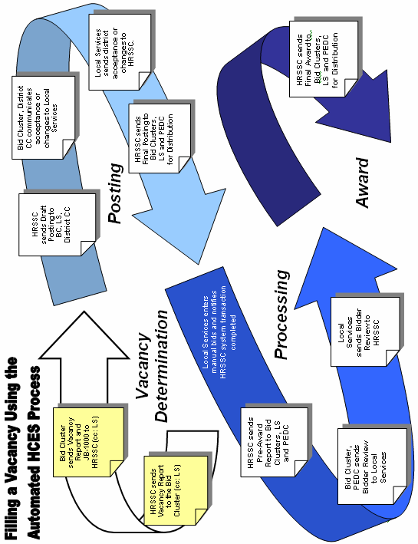

Posting Schedule Process Steps:

Once a year in November, HR Local Services must create and submit for approval each automated On-Schedule (OS) Bid Clusters’ posting schedule for the following calendar year. In addition, anytime during the year, when authorized by the JBM Project Manager to automate an additional OS Bid Cluster or craft, a posting schedule must be created and submitted for the remainder of that calendar year. The submitter must have an eAccess approved “FIELD USER” access level to add schedules in the JBM Schedule Tool. Schedules for all Post on Request (POR) Bid Clusters will be entered into the scheduling tool by HRSSC as they are submitted.

HINT: The entire schedule tool can be viewed on one page without using scroll bars by changing your screen resolution to 1152 by 864 pixels.

TO ACCESS THE JBM SCHEDULE TOOL
- Click on http://hrssc/jbmnp/!jbm_sso_std.logon
- Log In using ACE ID & ACE Password
- Click on Manage Schedules
- Use the drop down menu to select: calendar year, area, district, bid cluster.
- Click on the link “Search by Bid Cluster ID” and enter the specific Bid Cluster ID.
- Click on NEXT found at the bottom left side of the screen.

TO ADD A NEW SCHEDULE (DURING AUTHORIZED TIME FRAMES)
- At the bottom of the screen, click on ADD NEW SCHEDULE.
- Approval Status will always be EDITING.
- Posting Type: AUTOMATED is the only choice.
- Open Date: Enter open date of posting or use the calendar icon to select the open date – make sure to select the correct calendar year.
- Close Date: Enter close date of posting or use the calendar icon to select the close date -make sure to select the correct calendar year.
- SELECT POSTING CYCLE using drop down menu: 14 day, 28 day or OTHER.
- SELECT CRAFT using drop down menu
- Enter any comments necessary to have the schedule approved
- Review all entries
- Verify Union acceptance according to local practice.
- Click on GENERATE SCHEDULE
- The Manage Schedule Screen with status of newly added schedule shows EDITING

SUBMITTING SCHEDULES FOR APPROVAL

- Notice approval status of schedules is EDITING.
- Comment boxes are not visible unless there is a comment.
- Red Font indicates Weekend or Holiday
- Click in the check box on the far right of the schedule to select for submission.
- SUBMIT check box only shows on the Editing Schedules screen.
- Click on SUBMIT FOR APPROVAL button on bottom of the screen.
- As schedules are approved or denied, the status will change.
- Please review JBM Schedule Tool screens daily until every schedule has been approved for the calendar year.
- You can export your schedules to excel for reviewing/correcting. Click on EXPORT TO EXCEL at the bottom of the screen.
- SAVE as excel file.

Actions Available on Schedules

For each line entry there are three (3) radio buttons to the left; each allows you to edit, delete, or add comments. Any comments entered into the comment section will note the date, time & user ID entering the comments and will save this information.

The placement effective dates are not documented in the Schedule Tool. Effective dates are determined by HRSSC based on the applicable National Collective Bargaining Agreement during the posting process.

Every year you must ensure you communicate to the HRSSC your valid placement effective dates for late November and December postings. This should be done before the Award Notice is finalized by the HRSSC as the effective dates cannot be changed.

******************************************************IMPORTANT****************************************************************
ENSURE THAT UNIQUE POSTING INSTRUCTIONS ARE CLEARLY DOCUMENTED IN THE COMMENTS SECTION OF THE JBM SCHEDULING TOOL. DECEMBER POSTING AND PLACEMENT INSTRUCTIONS ARE REQUIRED FOR ALL CRAFTS FOR WHICH SCHEDULES ARE SUBMITTED.
************************************************************************************************************************************

Vacancy Determination

The Vacancy Report (VR) is utilized by Bid Clusters to communicate information or changes to vacant positions in preparation for posting. Full Time Regular (FTR) and Part Time Regular (PTR), Vacant, Residual and Withheld positions are listed.

Key Vacancy Report Elements:
The displayed data reflects information as it currently resides in the HCES system. DO NOT make changes to this data. Any corrections or additions required are to be communicated in the “Changes” area at the upper left

Record any necessary corrections to information in the “Changes” area.

Indicate posting instruction by selecting, for each listed position, “Post No Changes”, “Revert”, “Take No Action”, or “Post with Changes”.

The displayed data reflects information as it currently resides in the HCES system. DO NOT make changes to this data. Any corrections or additions required are to be communicated in the “Changes” area at the upper left

Record any necessary corrections to information in the “Changes” area.

Indicate posting instruction by selecting, for each listed position, “Post No Changes”, “Revert”, “Take No Action”, or “Post with Changes”.

Vacancy Determination Process Steps:

Automated “Post on Request” (POR) Bid Cluster (BC)
Those automated Bid Clusters that post less than 9 times a year and are authorized by the HRSSC to use the POR process must submit JB-1050 “Request for Vacancy Report” as a vacancy occurs that requires posting.

Use of the JB-1050 worksheet by an unauthorized BC is not permitted.

The Part Time Regular Carrier (PTR CA) and Part Time Regular Mail Handler (PTR MH) automated bidding process is available to those Bid Clusters that currently post FTR CA and/or FTR MH vacancies through HCES and accomplished by HRSSC. The posting/bidding/awarding of PTR CA and PTR MH vacancies is accomplished by automated POR process only.

Those Bid Clusters that post FTR CA and FTR MH as a non-automated process accomplished locally may not take advantage of automated POR job bidding for PTR CA or PTR MH.

When positions are to be posted, a Vacancy Report is requested from HRSSC at least 10 days prior to the anticipated posting open date.
- Bid Cluster submits JB-1050 “Request for Vacancy Report” to “HRSSC JBM (Area name)”
  - Indicate Bid Cluster and contact information
  - Identify Craft
  - Provide the anticipated posting open date.
  - Enter an email address for delivery of the Vacancy Report
- The HRSSC forwards a Vacancy Report as requested and enters the schedule in the Scheduling Tool.
- Upon receipt, the Bid Cluster continues with the automated process steps below.

Automated Bid Cluster:
- Bid Clusters utilizing automated bidding will receive a Vacancy Report as an Outlook email attachment.
- Review the report when received and provide instruction for each position listed.
    - Position Status selections:
      - “Post No Changes” - position information is correct.
      - “Post With Changes” – indicate changes requested by entering text in the space next to the changes section only. Do not delete or make changes to report data.
      - “Revert”– Selected only when reversion process and union notification is completed. (If there is a need to revert between vacancy reports use JB-1200.)
      - “Take No Action” – This option indicates the position is not to be posted at this time. (These positions will continue to appear on a Bid Cluster’s “Vacancy Report” each cycle until they are filled or resolved.)
- Indicate any changes to position attributes
  - Verify information in the position comments.
  - Verify schedules, days off, routes, qualification requirements, schemes, skills, licenses, LDC, etc.
  - Verify accuracy of position location and organizational relationship.
- Communicate any corrections in the “Changes” section located at the top of each position.
- Save the document so that it can be attached to an email message. (Reference the “Information” section of the Job Bidding Toolkit for “save” and “attachment” instructions.)
- Complete JB-1000 “Automated Posting Vacancy Coversheet” .
    - Enter Open and Close dates for this posting.
    - Document any LMOU provisions affecting the posting or awarding of these positions.
    - Provide additional comments which impact the posting,
- Submit the completed Vacancy Report and completed JB-1000 “Automated Posting Vacancy Coversheet” to HRSSC via Outlook email to “HRSSC JBM (Area name)” as indicated in the JBM Schedule Tool, usually within 3 working days of receipt. Copy your District HR Local Services office on your message.

********************************************************* IMPORTANT ***********************************************************
VERIFY INFORMATION FOR EACH LISTED POSITION THOROUGHLY BEFORE SUBMITTING.
*************************************************************************************************************************************

Posting Process

The Vacancy Notice (Bid Posting) is the document which is displayed for employees’ consideration.

Key Vacancy Notice (Bid Posting) Elements

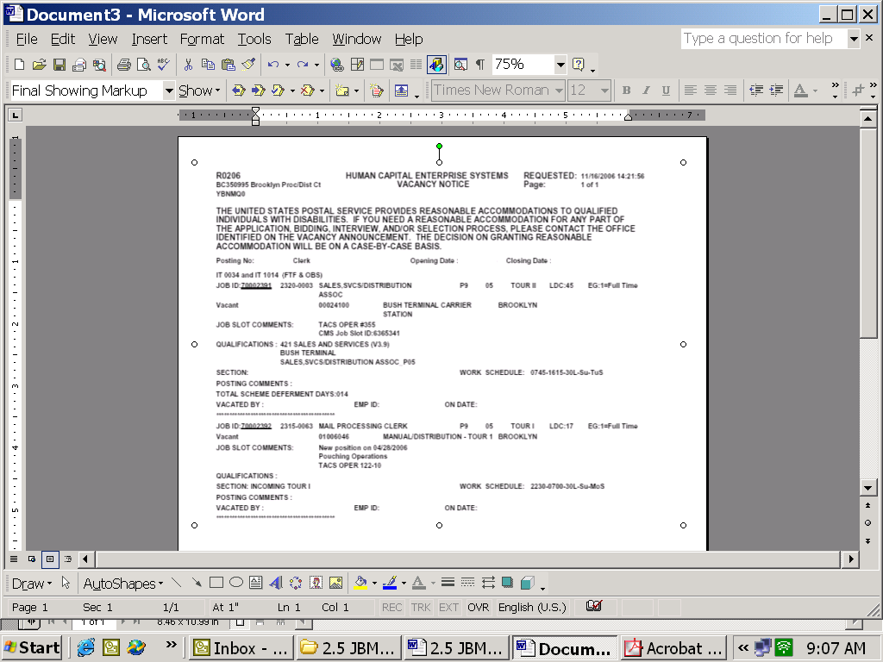
Posting Number and Craft
Posted Position Detail Information
Open and Close Dates
Schedule Information
Current HCES Position Number and previous CMS Job Slot
Posting Number and Craft
Posted Position Detail Information
Open and Close Dates
Schedule Information
Current HCES Position Number and previous CMS Job Slot

Review of Positions and Finalization of Posting

Automated Bid Cluster:
- The Bid Cluster will receive, via email, a Draft Posting as indicated in the JBM Schedule Tool, approximately 4 business days prior to the scheduled open date.
    - Upon receipt review positions for accuracy and indicate needed revisions. (This review is the last opportunity for revisions to the positions or posting information)
    - Submit the review information via email to your District HR Local Services office within one business day. Communicate instructions and/or acceptance in the body of the email message.
Note: Where 14 day bidding cycles are used, no Draft Posting is created. HR Shared Services will create the Final Posting from the submitted JB-1000 and Vacancy Report information.

District Complement Committee (CC):
- The District Complement Committee (CC) will receive, via email, a courtesy copy of the Draft Posting prior to the scheduled opening date. This is the final opportunity for review of positions being posted and is provided to accommodate varying District practices. If the District CC currently requires a review or approval of positions to be posted, it is accomplished at this time. Local District policy dictates this step and is optional in the overall standard process.

District HR Local Services:
- You will receive, via email, a Draft Posting as indicated in the JBM Schedule Tool, approximately 4 days prior to the scheduled opening date.
    - Collect any feedback received from the Bid Cluster.
    - Forward review findings to HR Shared Services via Outlook email message to the “HRSSC JBM (Area name)” no later than 12:00 noon ET, as indicated in the JBM Schedule Tool, 2 business days prior to the posting’s scheduled open date. Communicate instructions and/or acceptance in the body of the email message.
Note: It is recommended that the Bid Cluster’s Vacancy Report be run for identification of any positions vacated after the HRSSC sends the vacancy report. Submit these positions along with review results for inclusion in the finalized posting.

HRSSC will finalize and forward the Final Posting no later 12:00 noon, BC time zone, as indicated in the JBM Schedule Tool, one business day prior to the posting’s scheduled open date.

*************************************************************** IMPORTANT******************************************************
ONCE FINALIZED, A POSTING CANNOT BE REVISED. POSTING DATES CANNOT BE EXTENDED. POSITIONS CANNOT BE REMOVED.
*************************************************************************************************************************************

District HR Local Services:
- Receives the Final Posting via Outlook email.
    - Attach any locally generated coversheet or additional information per District practice.
    - Insure the accurate, consistent and timely distribution of all final postings.
    - Forward posting to Unions per local practice.

District PEDC/Training:
- Receives a courtesy copy of the Final Posting for planning purposes.

Automated Bid Cluster:
- Receives a courtesy copy of the Final Posting.
- Attach any locally generated coversheet or additional information per District practice.
- Physically posts the Vacancy Notice (Posting) immediately upon receipt.
- Mail a copy of postings to absent employees with written requests on file.
- Provide Union copies per local practice.

Manual Postings in Automated Bid Clusters
- Situations which require manual posting or local handling and are not automated at this time.
    - Best Qualified
    - In-Section bidding (except in previously approved situations)
    - Maintenance (continue to utilize ABID or other current practice)
    - MVO/TTO
    - Rural Carriers
    - Unique LMOU situations
  - Post these positions following manual posting procedures and local practices and communicate result to HRSSC for placement on JB-1200/1200R as applicable.

Accept Bids Process
At 12:01am Central Time, on the scheduled day, the Posting opens for employee bidding and is available immediately through automated bidding applications.

Employees:
- Submit requests in writing to your manager for a copy of posting(s) scheduled to open during approved absences.
- Enter bids through automated processes during the posting open period.
    - EIN and PIN are required to access IVR (phone), kiosk and computer applications.
    - Report any problems with automated bidding equipment to your manager immediately.
    - Submit manual bid cards (PS1717) where contractually accepted per local practice.
  - Withdraw bids via the same method in which the bid was submitted prior to the posting close date.
  - Submit PTF Preferences in writing per local practice for eligible residual positions.
- Submit any required medical documentation to HR Local Services as local practices dictate.

Automated Bid Cluster:
- Collect manual bids (PS1717) where contractually accepted and forward to District HR Local Services immediately upon receipt but no later than “Close of Business” the last day of the posting.
    - When manual bid cards are accepted in emergency situations due to technical problems, etc., inform the District HR Local Services office as soon as possible.
- Physically remove posting immediately upon closing.

District HR Local Services:
- Enter manual bid cards (PS1717) as received into the HCE system.
- To withdraw a bid, you must first enter and then withdraw the bid so that it is recorded for history.
- Within one business day after the posting closes complete manual bid entry.
- Run the “Manual Bid Entry Complete” transaction in HCES. Once this transaction has been completed, bid entry is no longer possible. In the event of an emergency contact the HRSSC immediately.
- Send an email message to “HRSSC JBM (Area name)” to indicate bid entry complete even if there are no manual bids to enter. Be sure to use the standard Subject line.

****************************************************************IMPORTANT******************************************************
NOTE: THE MANUAL BID TRANSACTION MUST BE COMPLETED FOR ALL AUTOMATED POSTING WHETHER OR NOT MANUAL BIDS ARE ACCEPTED.
**************************************************************************************************************************************
At 11:59 PM Central Time, on the scheduled day, the posting closes and is removed automatically from the automated bidding applications.

Bid Processing

Bidder Review Process Steps

Automated Bid Cluster/HR Local Services:
As indicated in the JBM Schedule Tool, approximately 3 days after the Posting closes the Bid Cluster and HR Local Services will receive a Pre-Award Notice.

- Review each Senior Bidder on the report to determine if one of the following applies and mark as indicated:

1 ( ) Communicate if the senior bidder served in a non-bargaining, higher level/204B capacity during the bidding period for the posting.

Selection may indicate the position can not be awarded at this time. If you mark an “X” in option 1, the date and time of the employee’s bid submission must be compared to the PS 1723, Assignment Order. Please provide in the comments the dates/times served on higher level detail, or provide copy of PS 1723.

2 ( ) If the employee has a condition making it unlikely that he or she can currently perform the essential functions of the position, determine whether the condition is temporary or short-term, as opposed to long-term or permanent. In answering this question, you should gather information from the employee, including medical documentation. If the condition is temporary or short-term, can the employee produce medical certification indicating he/she will be able to fully perform the essential duties of the bid assignment within six months of the bid?

Selection may indicate the position can not be awarded at this time. If you mark an “X” in option 2, you must provide standard comments that are provided in one of the two bullets below. Please be sure you understand any possible legal/contractual ramifications of your choice (informational guidelines on next page):

      - Place an “X” in option 2 and document either “pending documentation” or “pending further review by a Reasonable Accommodation Committee (RAC)” in the ‘comments’ area of the report if the employee is given a period of time for submission or further consideration by the RAC will occur.

(These Positions will appear on the Final Award Notice as “Senior Bidder” with no effective date stated. The senior bidder will not be placed as “Successful Bidder” until Local Services sends the HRSSC JBM (your Area) mailbox notice that (A) proper medical certification has been received verifying that the employee’s illness/injury is temporary in nature and that the employee will be able to perform the essential duties/functions of the bid assignment within six (6) months of the bid or, (B) a determination has been made by the District Reasonable Accommodation Committee that the employee can perform the essential duties/functions of the bid assignment with or without reasonable accommodation. Another Final Award will be distributed for the position showing the effective date of placement.)

      - Place an “X” in option 2 and document “select next bidder” in the ‘comments’ area if: (A) the senior bidder has a temporary illness or injury, but fails or refuses to provide the requested medical certification, or (B) in the case of a senior bidder who has a permanent or long-term illness or injury, the RAC issues a determination that the Postal Service cannot accommodate the employee’s medical restrictions to allow him/her to perform the bid assignment.

Informational Guidelines:

- Bids submitted by employees who have temporary impairments or illnesses can be disqualified if the employee cannot provide the requested medical certification identified above.

- Bids submitted by qualified disabled employees cannot be automatically disqualified simply because the employee has permanent or long-term restrictions. Therefore, it is important to determine whether an employee with a permanent or long-term condition is disabled within the meaning of the Rehabilitation Act, and if so, whether the employee can be reasonably accommodated so as to enable the employee to perform the essential functions of the position.
- Before a qualified disabled employee’s bid can be rejected because of the employee’s permanent/long-term medical restrictions, the Postal Service must attempt to accommodate those restrictions. For a review of that process see Handbook EL-307, Reasonable Accommodation, an Interactive Process. If you are unsure whether or not an employee is disabled or what accommodations are reasonable, you can refer the employee’s bid to a Reasonable Accommodation Committee (RAC), where appropriate. See Manager’s Quick Reference Guide and Role of the Reasonable Accommodation Committee at...
http://blue.usps.gov/hrisp/ser/reas_accom.htm

Medical certification requests are tracked following current local practices and results are communicated by the Bid Cluster to the District HR Local Services office. When notifying the HRSSC of any results, please use the HRSSC JBM (your Area) mailbox.

District PEDC:
- Receive courtesy copy of the Pre-Award Report. Review the bidders for current qualification status when applicable.
- Where it is determined that training/qualification/skill information is not current, document the relevant information on a JB-1400, Training Qualification and Skills Worksheet and forward to the District HR Local Services office for inclusion with the Pre-Award review findings to the HRSSC to update the employees record prior to processing the final awards.

District HR Local Services:
- Coordinate the results of the Bidder verifications performed by the Bid Cluster, RAC and/or others and forwards to “HRSSC JBM (Area name)” via email no later then 12:00 noon (your time zone)of the designated date of return, as indicated in the JBM Schedule Tool.

Note: Where a bidder is determined to be ineligible the HRSSC will forward the Pre-Award Report again to reflect the next senior bidder for verification.
Pre-Award Report
The Pre-Award Report provides the opportunity for the review and verification of senior bidders prior to the final award.
Key Pre-Award Report Elements
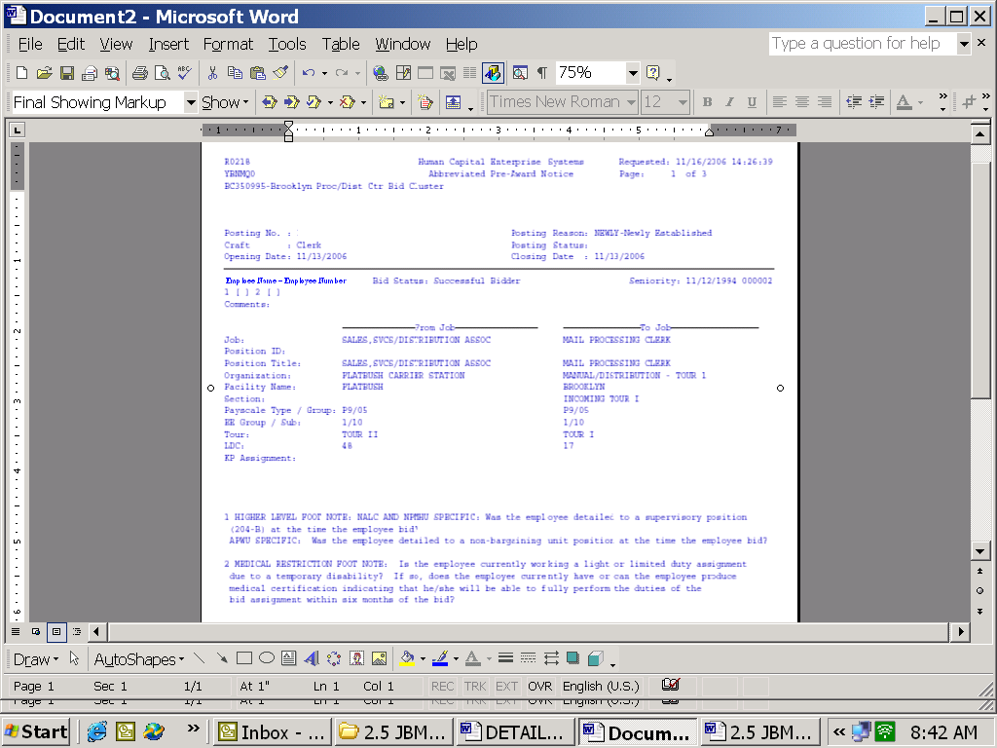
Area provided to communicate bidder information. See footnotes at the bottom.
Posting information
Explanation for the selections of options (1) and (2) listed above.
Employee’s current position
Position for which employee has bid
Area provided to communicate bidder information. See footnotes at the bottom.
Posting information
Explanation for the selections of options (1) and (2) listed above.
Employee’s current position
Position which employee has bid.

Effective the first posting of calendar 2009, the pre-award review must be returned to the HRSSC by noon (BC time zone) the day it is due.

Bid Awards

The Award Notice is used to communicate selection and placement of employees into posted positions at the conclusion of bidding activities.

Key Award Notice Elements
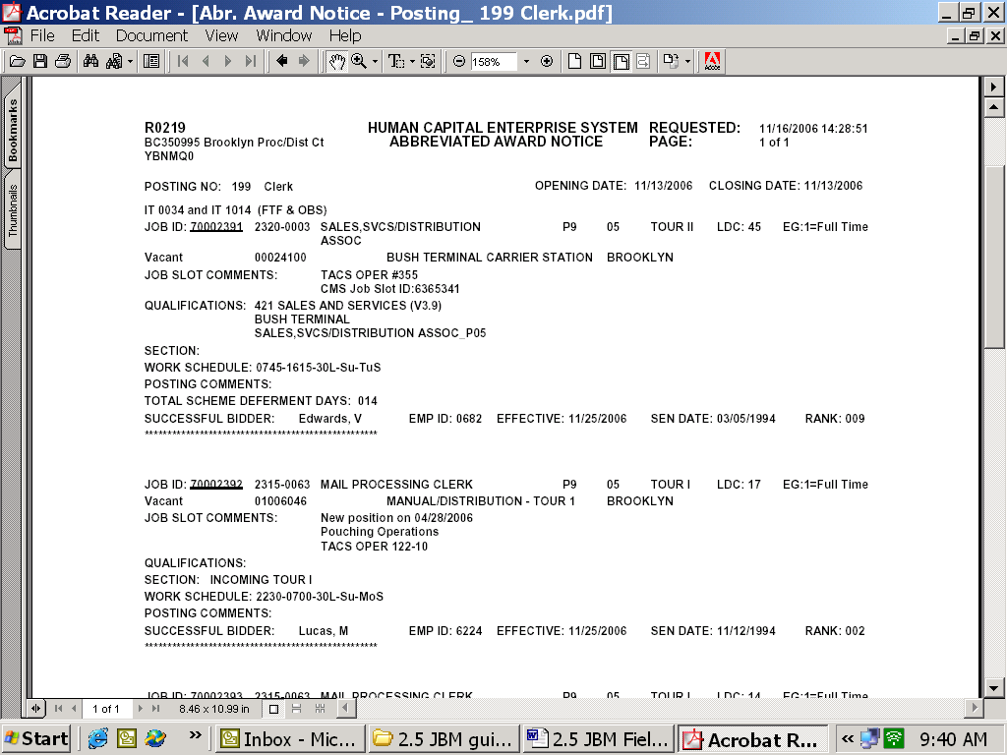
Bidder Information
Posting Information
Position Information
Bidder Information
Posting Information
Position Information

Award Bids Process Steps

District HR Local Services:
- As indicated in the JBM Schedule Tool, approximately 9 days after the posting closes, HR Local Services will receive the final Award Notice. (Additional Final Awards are distributed upon completion of Pending Qualification results and where employee medical issues are resolved.)
- Insure the accurate, consistent and timely distribution of the final Award Notice.
Provide written notification/instructions to successful employees per local practice.
- Forward award information to Unions per local practice.

Automated Bid Cluster:
- Receive courtesy copy of the Final Award Notice.
- Reproduce as needed and post Award Notice upon receipt.
- If “No Successful Bidder” positions result from the posting, communicate processing instructions to Shared Services.
    - Utilize JB-1200 “Request to Process Manual Bidding Results” (exhibit D) to communicate placement of fully qualified unassigned regular, full time flexible, etc., into residual positions.
    - Utilize RAR-200 “Authorization to Convert to Full Time” to request PTF conversion for CA, MH and CK positions.
    - All RAR-200 and JB-1200 worksheets must be submitted via email to “HRSSC RAR 200/JB1200 (Area name)”.

************************************************************IMPORTANT**********************************************************
STANDARD SUBJECT LINES ENSURE TIMELY AND ACCURATE PROCESSING FOR SUBMITTED WORKSHEETS. THE STANDARD SUBJECT LINE FOR SUBMISSION OF THE RAR-200 AND THE JB-1200 SHOULD USE THE FOLLOWING FORMAT: DISTRICT/BID CLUSTER/WORKSHEET #/EFFECTIVE DATE.
**************************************************************************************************************************************

District PEDC:
- Receive courtesy copy of the Award Notice.
- Per local practice, notify and schedule employees for training, testing or skills demonstration.
- Submit JB-1400 “Qualifications and Skills” (exhibit G) to notify HRSSC of all bidding related training or skills demonstration.
Submit for:
  - Each qualification as it is completed.
  - Each skill demonstration as it occurs.
  - To update license information as required and/or acquired.
  - For employees who did not contact training/PEDC within the required 10 days, “no shows” or failures.
  - For an employee’s withdrawal from training and/or unsuccessful attempts.
    - Report % completion prior to withdrawal when applicable (ref. APWU Article 37.3.F.7)
    - Report 4 hours training completed in 5 days when applicable (ref. APWU Article 37.3.F.3 and 37.3.F.4.

Employee:
- Submit “Live Bid” requests in writing to your HR Local Services Office.
- Test, demonstrate skill and/or enter training as scheduled.

Manual Bidding Process
This section will provide more detailed information related to the steps, timeframes and documentation required in the Job Bidding process for those Bid Clusters who do not utilize automated bidding technology, or whose bidding practices are not yet supported by the automated HCES, and the posting and awarding of bid positions are accomplished locally.

Overview

Post, Process and Award

Vacancies are posted, processed and awarded using current local practices. The awards, along with any position attribute changes made prior to posting, are communicated to HRSSC for entry into the HCE system using the JB-1200/1200R.

Additionally, within Automated Bid Clusters, manual posting and processing is required for:
    - Best Qualified
    - In-Section bidding (except in previously approved situations).
    - Maintenance (continue to utilize ABID or other current practice)
    - MVO/TTO
    - Rural Carriers
    - Unique LMOU situations

Manual Bidding Process Steps:

Vacancy Posting

Manual Bid Cluster:
- Create postings and post positions using current local and District practices.
The HRSSC will forward the position numbers of newly created positions to manual bidding facilities for local posting.
- Mail a copy of postings to absent employees with written requests on file.
- Provide Union copies per local practice.

Employee:
- Submit manual bids locally for vacated positions during the posted dates.

Manual Bid Cluster:
- Physically remove posting at the conclusion of the posting period.
- Collect bid cards (PS1717) or their equivalent and process locally per local practice.

Process and Award Bids

Manual Bid Clusters:
- Determine posting results locally.
- Create as needed, and post an award notice.
- Utilize JB-1200 “Request to Process Manual Bidding Results” to communicate placement of fully qualified employees into posted positions and include any changes to position attributes prior to posting for bid. Submit via email to “HRSSC RAR200/JB1200 (Area name)” for processing.
- Utilize JB-1200R “Rural Carrier Bidding Results” for placement of fully qualified regular rural carriers Submit via email to “HRSSC Rural Carrier (Area name)” for processing.

- Utilize RAR-200 “Conversion to Full Time” to request a PTF conversion for CA, CK and/or MH crafts. Rural Carrier conversions to career are accomplished through the applicable PA toolkit worksheet. All RAR-200 and JB-1200 worksheets must be submitted via email to HRSSC RAR200/JB1200 (your Area).

Training and Pending Qualifications
- In manually bidding Pending Qualification placements are not reported to HRSSC until qualification is complete and the employee is ready for placement
  - Submit JB-1200 with placement information ALONG WITH the JB-1400 documenting successful completion of the pending qualification to HRSSC RAR200/JB1200 (your area).

- For maintenance craft pending qualification placements, submit JB-1300 in situations when promotion is contingent upon satisfactory completion of training per Article 38.5.C.3.

Employee:
- Submit “Live Bid” requests locally, in writing per local practice.
- Test, demonstrate skill and/or enter training as scheduled.

Information, Questions and Answers
Information related to standard email messaging, the location of JBM materials online in the PostalPeople website, and answers to frequently asked questions related to Bid Management which may not have been addressed in the process steps are included in the following section.
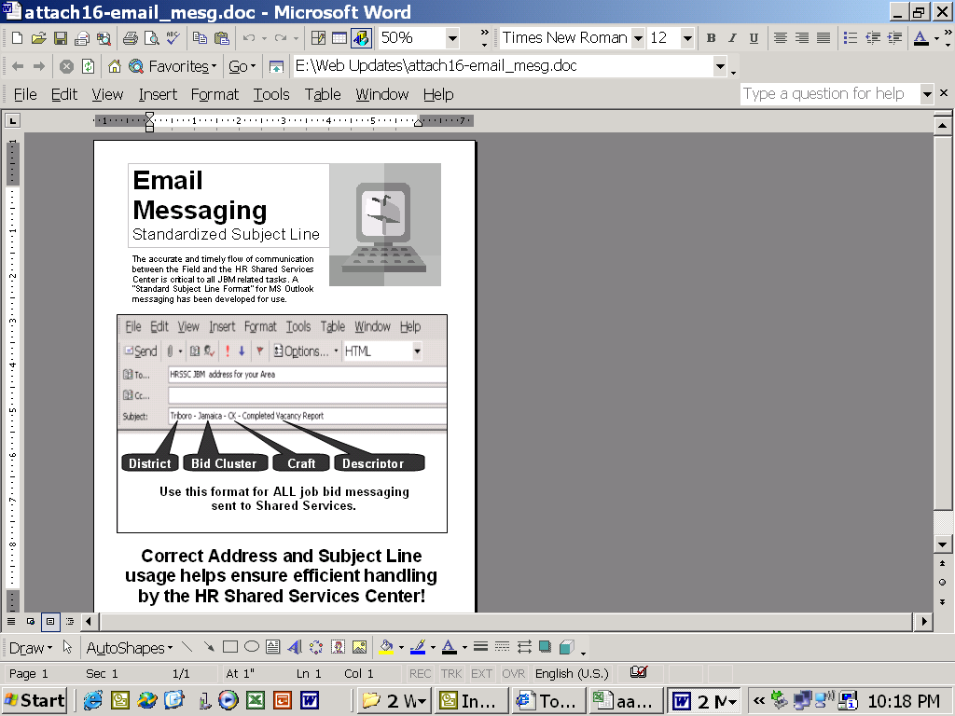

PostalPeople Toolkits

Worksheets and templates are critiqued and revised frequently. The most convenient way to access and ensure you have the most current version, or get additional information about their use, is through the “Tool Kits” or worksheets link on the PostalPeople website.

http://blue.usps.gov/hrisp/hce/toolkits.htm

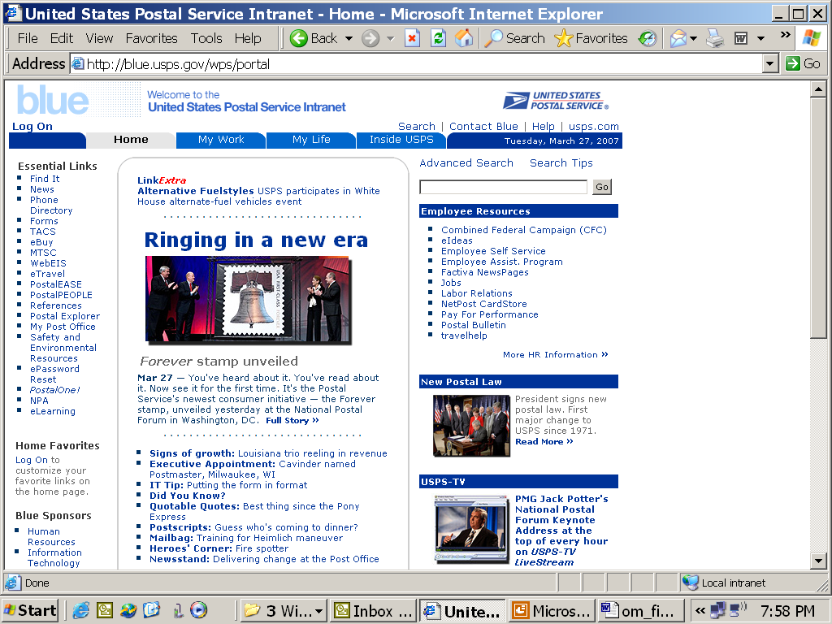
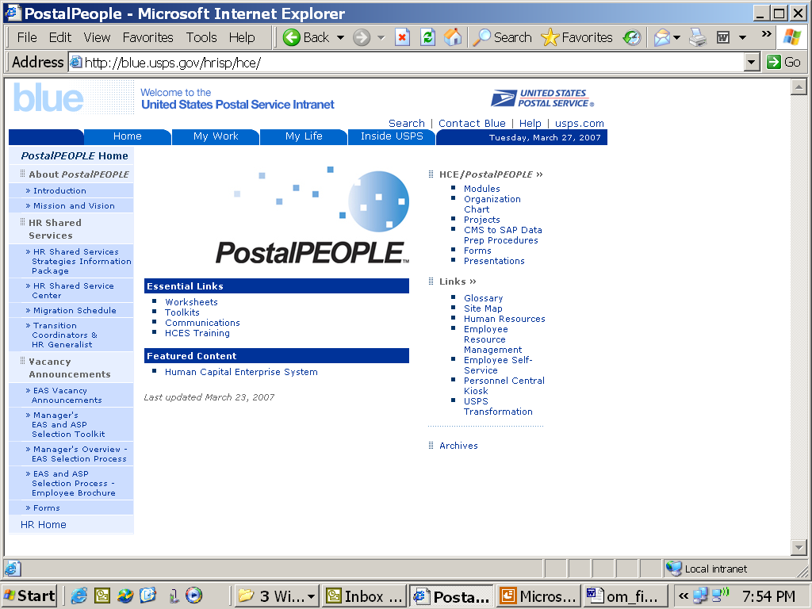

Tip! Have them right at your fingertips.
While at the “Toolkits” page, click your right mouse button. Select “Create Shortcut”. An icon will be added to your desktop that will allow you to go directly here from your desktop.

FREQUENTLY ASKED QUESTIONS

Should I send messages directly to a HRSSC Specialist?
Unless you are specifically instructed, all messages are to be sent to HRSSC as described previously in this document. Utilizing this process ensures that your messages will receive attention timely during normal operating hours. All worksheets contain instructions for proper submission.

How do I know where to submit information and worksheets?
Instructions for all job bidding submissions are contained in this guide. Worksheets contain information to assist with completion and submission. To avoid delays, or return of documents, submit only as instructed.

Some of the terminology has changed. What does “Cost Center” mean?
“Cost Center” is the equivalent of “Finance Number”. When using the online versions of the worksheets you’ll find comments imbedded which will offer assistance when passing your curser over the field. A collection of job bidding related term definitions is contained in this document in Section 7 and in the Job Bidding Toolkit under “Information”. A more comprehensive program “Glossary” is located at... http://blue.usps.gov/hrisp/hces/training/nav/index.htm

I’m an automated Bid Cluster. The Final Posting contains an error how do I get that corrected?
Once the draft posting report has been reviewed and HRSSC has finalized for distribution, changes are not permitted by the system. Care should be taken to ensure that any revisions are communicated during the draft review. Contact your HR Local Services Office and/or “HRSSC JBM (Area name)” immediately should an emergency occur.

When an employee is separated, when will their position appear on the Vacancy Report?
Positions are not available for posting until the Form 50 separating the employee has been transacted. Additionally, the effective date of the separation must be PRIOR to the closing date of the posting in order to be included.

I have positions that appear on my Vacancy Report cycle after cycle. Why is this happening?
This could happen for a variety of reasons. If you select “Take No Action” on your vacancy report or there is a pending decision on residual positions such as placement of an unencumbered employee, PTF preferencing or conversion, pending reversion, recruitment, being posted through a manual process such as a best qualified, or a position in pending qualification status, these positions will reflect each cycle, on each report, until the positions are filled or reverted.

I need to create and post a new bargaining-unit position. How is that done?
For both automated and manual bidding sites the new bargaining-unit position must first be created. Complete the RAR-100 worksheet “Request to Create New Position” and submit it to your Complement Committee for processing. Once the authorization is received, HRSSC will create the position as instructed and it will be available for placement on a posting and can be seen through Managers’ Portal. For automated facilities the position will be included in the regular vacancy report in the next posting cycle. For manual offices the newly created position number is communicated back to the BC by the HRSSC for local posting.

Who sends the posting to employees on vacation?
Each National Agreement has a provision that requires the installation head to mail a copy of postings to absent employees on approved leave who have so requested in writing, stating a mailing preference.

Who places the Vacancy Notice (posting) on the bid board?
The Vacancy Notice is to be placed by local management prior to opening and removed immediately after the closing dates.

How do I revert a position if I use the manual processes or between automated postings?
The JB-1200 “Request to Process Manual Bidding Results” is used for this purpose in the manual process. In the automated process the easiest method is to indicate the desire for reversion is on your Vacancy Report. If there is a need prior to the receipt of your next report you can follow the procedure above for manual processes.

What should I do if the automated bid equipment is not functioning?
Bid Cluster:
Gather as much information as possible and contact HR Local Services.
Information to note would include:
  - Employee name, employee EIN.
  - Bid Cluster, Craft, and posting number.
  - Which system is involved (phone, kiosk, bid computer)
  - At what juncture is the error occurring such as the system won’t accept pin, call disconnects, doesn’t display posting, etc.
  - Note any “error” message(s) received.
  - Is this an isolated incident or has there been multiple occurrences?
(Note: After 3 unsuccessful PIN attempts the system will lock the employee out for a 24 hour period.)

Bid Clusters must communicate with District HR Local Services if manual bids are accepted due to, or during, the system’s malfunction. If manual bids are accepted forward them to HR Local Services for processing immediately upon acceptance.

HR Local Services:
Note the nature of the problem and report immediately to District IT department for investigation. If the issue cannot be resolved locally (i.e. printer paper depletion, power interruption, etc.) contact the IT Help Desk at 1-800-USPS HELP to initiate a remedy ticket.

Managers’ Portal (MY WORK)

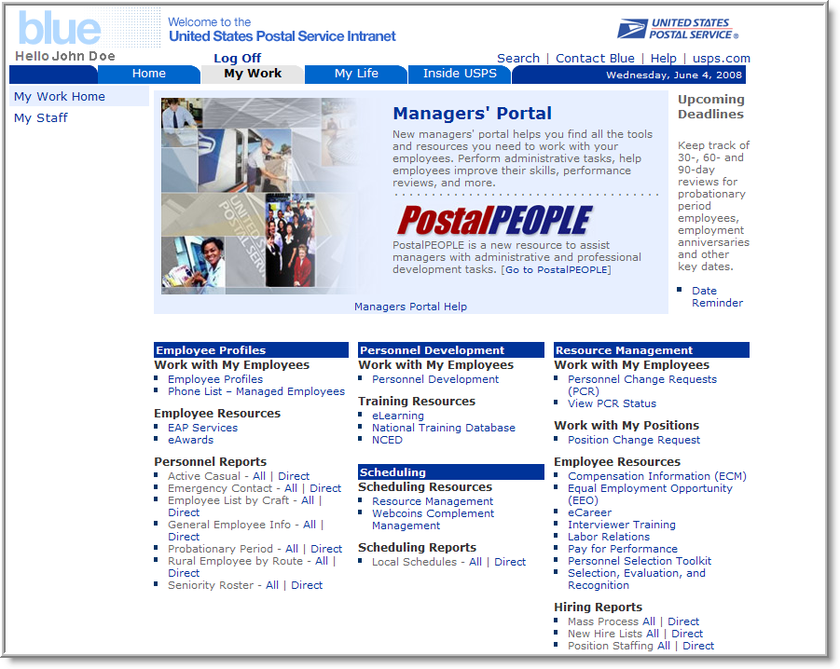

The Manager’s portal provides managers, which are designated as chiefs, the ability to log in and view information and resources to help manage their workforce, perform administrative tasks, and assist their employees with qualification and skills development.

This tool is located on the “Blue” page. In order to access this information, the managers must go to “Log On” on the upper left hand side of the Blue home page. Once the manager has logged on, and the system has authenticated them, they will click the tab “My Work”, then “My Staff” and the Managers’ Portal will appear. Managers will see the following information/reports:

Work with My Employees
In the Managers’ Portal a manager can view a list of their employees as either Direct Reports or All Employees. These are defined as follows:

    - Direct Reports – Only those employees who report directly to the manager. This consists of:
- All employees working in any organizational unit managed by the manager, plus
- The managers who work in organizational units that report directly to the manager’s
organizational unit (1st Echelon units)

    - All Employees – A list of the manager’s direct reports, plus
- All employees working in any organizational units that report to the manager’s unit (1st Echelon units) plus
- All employees working in any organizational units that report to one of the manager’s 1st Echelon units (2nd Echelon units). This is sometimes referred to as “two-level” view, but the term “level” has other meanings at USPS so, for now, we will refer to them as “echelons”.

Employee Information and Resources
- Employee Profiles – Manager’s can find general employee information in this section such as:
  - Hiring Date
  - eMail address
  - telephone number
  - organizational assignment
  - organization assignment history
  - emergency contact
- Phone List – employee’s work location telephone number.
- Personnel Development – this function lists employee’s skills, qualifications and certifications.
    - *Personnel Change Requests (PCR) – this function will initiate a voluntary separation from the USPS.
    - View Personnel Change Requests (PCR) – this function shows the status of a Personnel Change Request.
    - Position Change Request (OM-400 and OM-450) (PCR) – this function will initiate a change request to a non-bargaining or bargaining unit position where posting or reposting is not required. Requests must be in compliance with appropriate contracts, LMOU’s or EAS agreements.
    - Compensation Information – this feature displays employee’s salary and PFP information.

Reports
All reports can be printed

Personnel Reports
    - Active Casual – shows all active casuals under the manager’s jurisdiction.
    - Emergency Contact – a listing of employee’s home phone numbers, addresses, emergency contact designee’s name and telephone number(s).
    - Employee List by Craft – a listing of all employees listed under that manager. A sort can be initiated to separate the employees into their respective crafts.
    - General Employee Information – employee name, employee identification number, organizational ID, job ID, cost center, enter on duty date, job name, organizational name, placement date, non-schedule days, tour start/end times.
    - Probationary Period – a listing of probationary employees within a manager’s organization.
    - Rural Employee by Route – a listing of all rural carriers in the manager’s organization.
    - Seniority Roster – a listing of employees by seniority. A sort can be initiated to separate the employees into their respective crafts.

Scheduling Reports
    - Local Schedules – a listing of all employees, their non-scheduled days and start/end times.

Hiring Reports
    - New Hire Lists – all new employees hired for a pay period.
    - Position Staffing – lists all authorized and actual positions under the manager.

Upcoming Deadlines
Date Reminder – keeps track of Employee Evaluation and/or Probationary Reviews (30, 60, 80 bargaining unit employees and 30, 60, 80, 150, 170 PCES/EAS employees); employee service anniversary, NTE and other key dates.

Employee Self Service (ESS – MY LIFE)

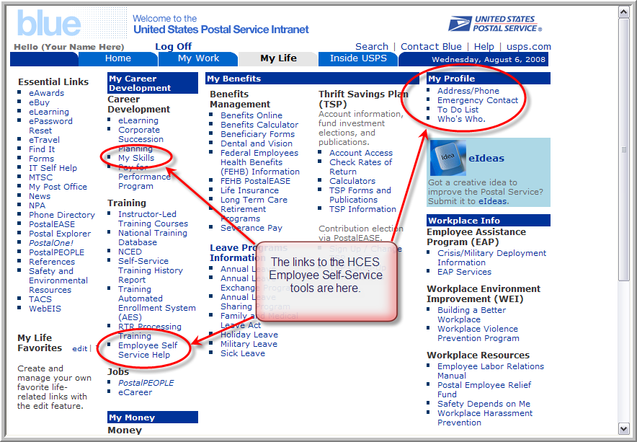

Employee Self Service is a tool that all employees who have access to the “Blue” page can utilize. This portal provides employees the ability to log in and view information and resources that affect their personal lives (My Life).

This tool is located on the intranet “Blue” page. In order to access this information, the employee must go to “Log On” on the upper left hand side of the Blue home page. Once the employee has logged on, and the system has authenticated them, then they will click the tab “My Life”. Employees will see the following information:

My Profile
    - Address/Phone Number – this feature allows all users (who have an ACE login and password) to update their residence/mailing addresses and personal phone numbers. The system will display messages informing you there is a 28 character limit on the first address line, and that to change your address for Savings Bonds, you must enter the changes on the Postal EASE Employee Self-Service page.
    - Emergency Contact – this feature allows all users to update their emergency contact designee and phone numbers.
    - Employees can also change their address, phone number and emergency contact on Lite Blue – Home.

    - To Do – the following features are contained in this field:
    - Tasks – a request for a work process
    - Alerts – task that needs to be completed
    - Notifications – when a workflow is available
    - Tracking – status of a task
    - Who’s Who – this feature allows all users to look up telephone numbers and locations of employees who are in the Human Capital Enterprise System (HCES). The user can change their work phone number and work email (if one is listed).
My Skills – this feature allows all users to examine their skills, certificates, and qualifications that were assigned to their profile in the Human Capital Enterprise System (HCES).

Additional Information

Chief Designation (OM-450 section 3 is used to change this designation)
- EAS or PCES employee who acts as the point of contact with HRSSC for administrative matters pertaining to a group of employees (Subordinates).
- Only one Chief per organization unit.
- An organization unit without a Chief inherits the chief role of the managing organizations.
- Chief/subordinate relationship is used to manage workflow and to facilitate communication up and down throughout the organization.

Electronic Workflows*
- Form 50 notifications – future dated accessions, separations, retirements, and transfers
- Probation Period Notifications
- Voluntary Separation

* The above workflows are presently not turned on.

APPENDICES/ EXHIBITS

APPENDIX 1: HCES Organization Management Maintenance Responsibilities

Organizational Effectiveness (OE)
Create and maintain all Jobs in current structure.
Create and maintain all organization data for HQ and HQ related units.
Design and create guidelines for all substantial structure and staff changes (mass changes) or national changes.
Create and maintain non-bargaining and HQ and HQ-related bargaining authorizations.

Area HR Staff
Create and maintain organization for field units in current structure.
Execute organization substantial structure and staff changes (mass changes) within OE guidelines.
Assure that all EAS, PCES and other “authorizable” Positions are Authorized via 9130 entries.
Process and approve all change requests received from their field units.

HRSSC
Create and maintain Positions (formerly CMS Job Slots) for field locations in current structure.

Field Management and Local Services
Although field managers and Local Services do not have access to HCES to update positions themselves, they communicate to the HRSSC through their Area HR office any changes to positions and organization structures based on operational requirements.

APPENDIX 2: Human Capital Enterprise System Terms vs. CMS Terms

HCES Term | Definition | Equivalent CMS Term
Personnel Area | An organizational entity representing an area within the USPS, defined by specific aspects of personnel administration, time management and payroll. | Field: Area (Cap Metro, Southeast, etc)  HQ: Division (HQ, OIG, IS, PRC, BOG, etc.)
Personnel Sub-area | An organizational entity which represents part of a personnel area. | Field: District or Performance Cluster  HQ: Department (Finance, Operations, etc.)
Cost Center | A financial object that exists to capture incurred expenses from the organizational units and positions related to it. | Finance Number
Employee Group / Employee Subgroup | Two codes, assigned to a position, which identifies the position as Full Time, Casual, Management/Supervisor, etc. and describes the type of work a person holding this position would normally perform. | Designation/Activity Codes (Des/Act)
Job | An organizational object (object type C) that represents a general classification of duties. These duties, together with other unique attributes are passed on to all related positions in the organization. | Occupation Code
Position | A position (object type S) is an organizational object, assigned to an organizational unit that represents a specific instance of a job and may be occupied by an employee or vacant. Most attributes of a position are inherited from the related job. | Job Slot
Chief Position | A position that has a “Manages” relationship to an organizational unit, indicating that the position holder is the manager of the unit. | Manager position
Organizational Unit | An organizational unit (object type O) represents any type of organizational entity found within the USPS, for example, areas, districts, post offices, carrier stations, or special project teams. | Unit (Plant, Post Office, Dept., Tour, etc.)
Installation Head | A designation given to an organizational unit that identifies it as the principal entity in a grouping of units. Settings unique to installation heads are maintained in a unit’s Installation Head info type. | Roughly equiv. to Lead Finance Number
Pay Grade | The equivalent of “level” for EAS, OIC, PCES and APS jobs that are paid on an annualized basis. | Rate Schedule Code, EAS Level
Pay Scale Group | The equivalent of the grade level for jobs that are paid on an hourly basis. | Grade

APPENDIX 3: Cost Center Changes – Mass Reassignment Field and HQ Instructions

Cost Center Changes – Mass Reassignment Field and HQ Instructions

The purpose of these instructions is to guide you through the process of mass reassignments involving one of the following scenarios:

- All employees stay in their current organization and the cost center changes. Example: Station has a cost center but a decision is made to change the cost center.
- All employees move from their current organization and cost center to a NEW organization and NEW cost center. Current organization and cost center will be discontinued. Example: Close an AMC and employees are moving into the P&DC.
- Some employees within the same organization move from existing cost center to a NEW organization and NEW cost center. Both cost centers are to remain in existence. Example: Create a new Carrier Annex and some employees at a Main Office Carrier Unit will be moved to the new Carrier Annex and others will stay at the Main Office Carrier Unit.
Steps to Implement Changes:

- In all scenarios above the Area and/or District will provide to the HRSSC via Area OM mailbox, the number of employees and positions involved in the change along with the effective date of the change, which MUST be the beginning of a pay period. This message must also include whether the move entails creating new positions or if the old positions are to be used, and any changes to bid cluster or alternate bid cluster. Send information to the appropriate mailbox with the following in the subject line: Future Mass Reassignment/District Name/ Effective Date
The Area OM Mailboxes are:
HRSSC OM Capital Metro
HRSSC OM Eastern
HRSSC OM Great Lakes
HRSSC OM New York Metro
HRSSC OM Northeast
HRSSC OM Pacific
HRSSC OM Southeast
HRSSC OM Southwest
HRSSC OM Western
For HQ, due to the sensitivity of OM changes, all communication will be sent to the HRSSC – send to Dorothy Barrett and William D. Davis.
- This must happen as early as possible after the Area, District or HQ is aware of the change and knows the impact of the change.
- Area, District or HQ will follow up after the first notification to the HRSSC with the OM500 providing a list of employee names and positions (including vacant positions) affected by the change. This list will be an excel spreadsheet pulled from HCES PPOSE. Instructions to obtain this are:
PPOSE – Generate then extract the print image for Excel
- First find the unit for which you need to provide data. (The sample case targets Personnel Services unit, # 46146, within the Human Resources unit of the Triboro District.)
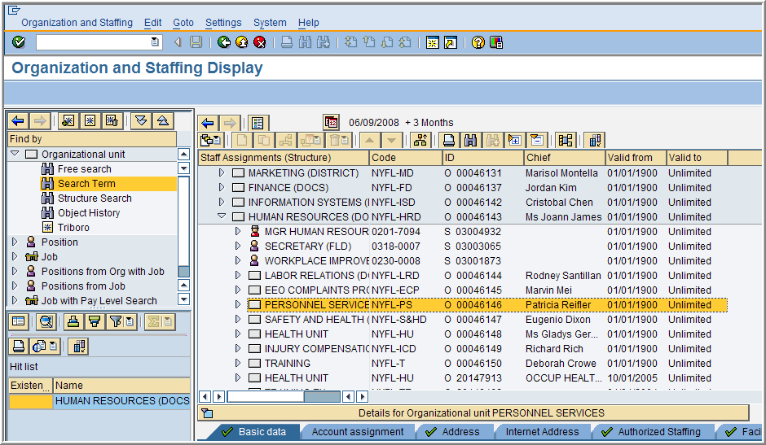
With that organization highlighted, click “Expand Node” to open all of the Positions within the selected structure.
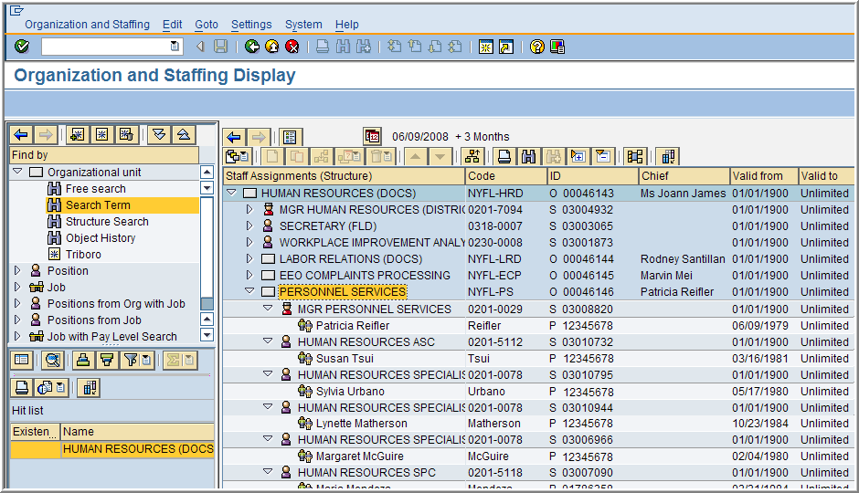
Then click “Print” to shift to a print preview. The result will be similar to the view shown below.
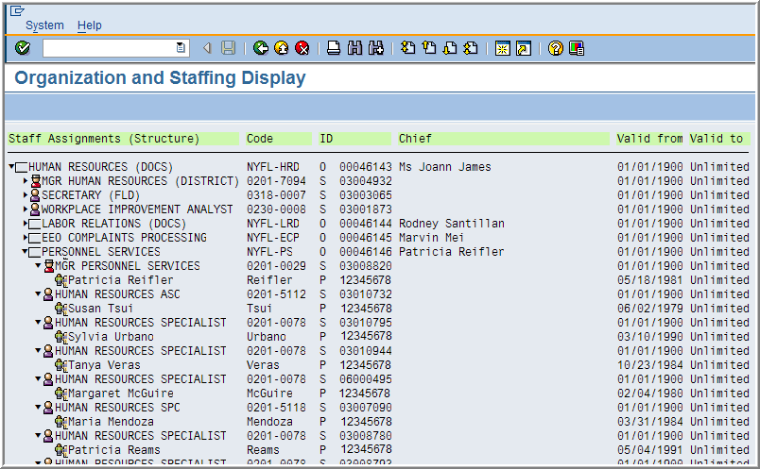
Using the “System” menu at the top of the window and select System>List>Save>Local File.
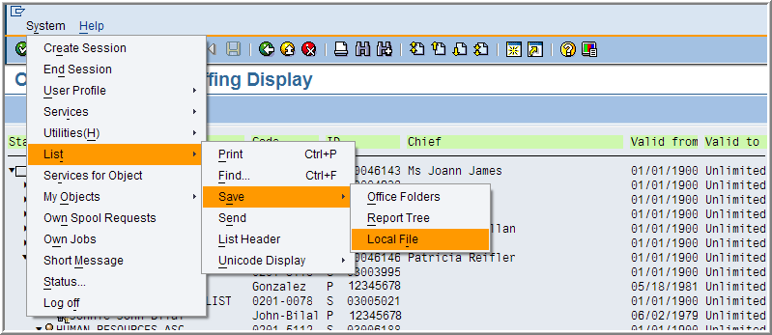
A “Save list in file…” dialog box appears. Select the “Spreadsheet” format.
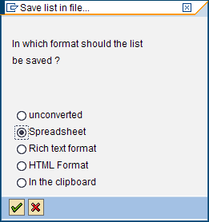

Click “Continue” .
Create a file name and identify the folder (Directory) where it will be saved.
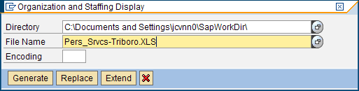
Click to create the file. Next, locate and open the file in Excel.
Note: If Excel considers it to be a text file, you can rectify it by using the Text Import Wizard as shown below.
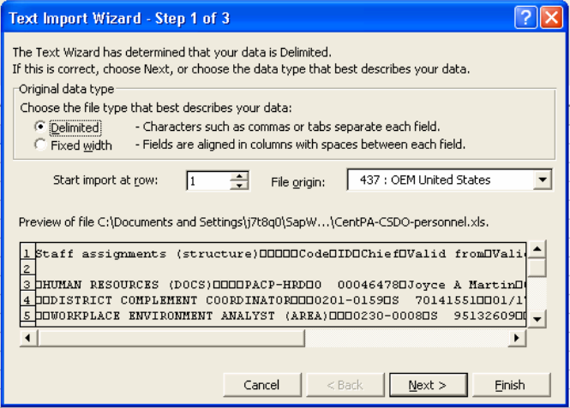
The file is delimited with tabs, so click Next> Next>Finish
A little clean up of the extra rows and columns and you have a list of all positions and people within the organization.
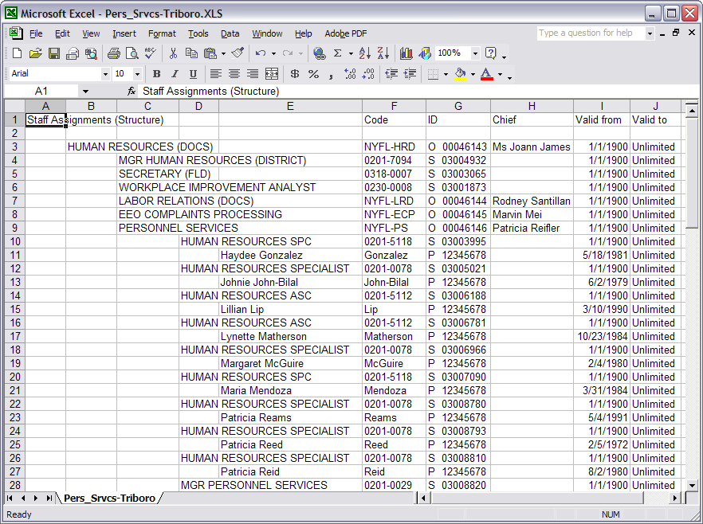
Finally, “Save As” to retain the sheet as an Excel spreadsheet.
- Ensure that everyone is aware of the effective date of the change as it will impact JBM bidding and postings, e-Career postings, pending qualifications, and forms 50 actions.
- If pay locations are affected the Area, District or HQ must provide local TACS with new pay locations at least two weeks prior to effective date of change.

Forms 50, JBM and e-Career:

- All JBM and e-Career postings must be awarded or cancelled no later than the day before the mass reassignment effective date, which MUST be the beginning of a pay period.
- If JBM or eCareer postings have been awarded with an effective date LATER than the mass reassignment effective date; the Area, District or HQ must contact the HRSSC so they can cancel the placements (form 50, non-form 50 and pending qualifications). The employees will be placed into the new position and cost center after completion of the mass reassignment. The selecting official for EAS positions MUST be made aware of the OM reassignment and must select the pay period before or after the mass reassignment.
- No JBM or eCareer postings are to be open or awarded the same date as the mass reassignment effective date. It must be the pay period before or the pay period after the mass reassignment.
- Do not create JBM or eCareer postings until after the mass reassignment have been completed.
- Instruct the HRSSC to temporarily cancel all pending qualification placements noting the position numbers for reference in order to place the employee into the positions after mass reassignment is completed.
- EAS Mailboxes for all e-Career related mail:
HRSSC EAS Cap Metro
HRSSC EAS Eastern
HRSSC EAS Great Lakes
HRSSC EAS HQ
HRSSC EAS HR External
HRSSC EAS Northeast
HRSSC EAS NY Metro
HRSSC EAS Pacific
HRSSC EAS Southeast
HRSSC EAS Southwest
HRSSC EAS Western
- For any JBM related correspondences send to your appropriate HRSSC JBM email account.
Positions
- In scenario #1 when the cost center is changed the positions, including vacant positions, will inherit the new cost center. The Area, District or HQ must provide the HRSSC with the OM500 along with the attachment of employees and positions impacted so forms 50 can be produced for the cost center change.
- In scenario #2 the Area, District or HQ must provide the HRSSC with a list of new positions if the current positions are not being used for the change. This will be an attachment to the OM500. The Area, District or HQ must also include all vacant positions and instruct the HRSSC as to which positions are to be moved, reverted, etc.
- In scenario #3 the Area, District or HQ must provide the HRSSC with a list of new positions if the current positions are not being used for the change. This will be an attachment to the OM500. The Area, District or HQ must also include all vacant positions and instruct the HRSSC as to which positions are to be moved, reverted, etc. Also providing a list of positions that will stay in existing cost center would be helpful for the HRSSC, and again this includes vacant and occupied positions.
Organizations
- In scenario #1 OE and/or Area OM can set up a cost center with a future effective date for the organization unit however it is imperative that coordination take place between HRSSC and OE and/or Area OM so the employee’s personnel actions coincide with the effective date of the change to cost center in OM.
- In scenario #2 OE and/or Area OM creates the new organization and adds the cost center with the effective date coordinated with HRSSC, however the old organization can not be delimited until ALL of the positions are either delimited or moved out of the organization unit. You should never delimit an organization with active positions attached. Coordination must be developed between Area OM and District offices and OE and Corporate Personnel Management (CPM). The HRSSC must receive the proper forms from the field and HQ CPM instructing them what to do with the positions in an organization that will be delimited.
- In scenario #3 OE and/or Area OM simply creates the new organization and adds the cost center with the effective date coordinated with HRSSC.
Chiefs

- The Area, District or HQ must provide to the HRSSC any changes to chief positions.
- There must be only one chief per organization unit.

Appendix 4: DETERMINING EFFECTIVE DATE OF REMOVALS
Reference: Postal Bulletin 21657, dated 2/4/1988 page 2

Effective dates of removals are determined by:
- If not appealed through administrative procedure, the effective date of the action is the date set forth in the notice of decision of removal as appropriate.
- If employee appeals a removal notice through administrative procedures, the effective date must be the date of the arbitrator’s decision.
- If the appeal is withdrawn, the effective date is the date of the withdrawal.

THIS PAGE

INTENTIONALLY

LEFT BLANK

