Network Distribution Center (NDC) Activation

Retail Unit Communications

July 15, 2009

Table of Contents

1 Overview 1
2 Service Talks 3
3 Reference Materials 13
3.1 Retail Operations website 13
3.2 Visual Aid 14
3.3 Sample Retail Distribution Placard 16
4 Readiness Assessment Checklist 17
5 APPENDIX A - Retail Distribution Code (RDC) Request Process 20
6 APPENDIX B – Container Placard Examples – Dispatched from Retail Units 23
7 APPENDIX C – Parcel Return Service 26
8 APPENDIX D – Frequently Asked Questions 29

Overview

POSTMASTER/ STATION MANAGER/ BRANCH MANAGER/ SUPERVISOR

Subject: Training Instructional Worksheet

The training package for delivery and retail personnel consists of approximately 30 minutes of training.
Training Specifics
Who Receives Training: All clerks and EAS employees working at Post Offices. This includes retail associates, carriers, distribution clerks, Postmasters, Managers and Supervisors.

Trainer Administrator: Postmaster, Station Manager, Branch Manager or Supervisor

Approximate Training Time: 30 minutes

Messaging Course Number: Retail Associate (RA’s) Course # 18201-71
Clerks and RA’s Course # 18201-73
Delivery Carriers Course # 18201-73
EAS Managers Course # 18201-73
Training Packet Includes:
- Guide to Training
- Service Talks
- Poster – PVI (RDC Separations)
- Self Readiness Assessment Checklist
- Employee Training AttendanceTracking Sheet
- Appendices

GUIDE TO TRAINING WORKSHEET

Step 1 – Review all materials in training packet. If there are missing items, contact your NDC Coordinator.

Packet should include the following items:
- Standup Talks
#1 NDC Overview
#2 Retail Distribution Code Labels
#3 Mail Prep and Dispatch (Retail Associates and Clerks)
#4 Missent Mail
#5 Parcel Return Service (PRS) & Non-Machinable Outsides (NMOs)
#6 Mail Prep and Dispatch (Carriers and Back-Office Clerks)
- POSTER – Retail Distribution Code(RDC) Separation
- Training Attendance Record - Complete after training; copy and maintain locally; and send a copy to PEDC who will enter into the NTD

Step 2 – Schedule Training
All retail associate and distribution clerks, carriers, and EAS Managers/supervisors

Step 3 – Administer Training
URL: http://blue.usps.gov/retail/L2Workforce_F4.htm
- Hang Visual Aid for RDC Separation (Locally developed)
- Conduct Required Standup Talks
- Complete Training Record – Messaging Course Number
- Attachment – Standardized Placards, Containerization guidelines, and special handlings
- Self Readiness Assessment; include make-up of RDCs prior to site implementation
- Review Appendix for Instructions to support NDC network by Retail Units

Service Talks

SERVICE TALK #1
NDC Overview

Target Audience – All Employees

Overview

The Postal Service is experiencing an unprecedented decline in mail volume with the current downturn in the economy. Last year mail volume declined by 9.5 billion pieces and we project an additional decline of 12-15 billion pieces this year. It is vital that we realign our network to reflect this new reality and eliminate excess capacity in equipment, staffing and facilities if the Postal Service is to remain viable.

The BMC network was set up in the 1970s to process Parcel Post, Bound Printed matter, Media Mail, Standard Mail (catalogs, parcels and bulk mail) and Periodicals. With the volume decline and changes in the mail mix, much of the mail the BMCs previously processed has gone away. Even before the downturn in the economy, mailers were drop shipping mail directly to the delivery units, bypassing the BMCs entirely.

In order to fully utilize the BMC facilities and consolidate transportation, we are changing how mail flows through the BMC network. As part of this change, we are converting BMCs to Network Distribution Centers (NDCs). Under the plan, existing BMCs will be realigned into three tiers of NDCs. Tier 1 sites will only process destinating mail and originating turn-around mail for the Tier 1 service area. In the longer term, Tier 1 sites will also have STC containerization and dispatch functions. All mail for destinations outside of the Tier 1 service area will be sent to Tier 2 sites for processing and dispatch. Tier 2 sites will process the same mail they do today plus all of the outgoing mail from Tier 1 sites. Tier 2 sites may perform single piece distribution of letters and flats and containerize and dispatch First-Class and Priority Mail. Tier 3 sites will be the gateway sites for consolidating mail from the Tier 2 sites when they are not able to send out full truckloads to the network.

We began implementation of the NDC concept in May 2009. Phase I of implementation occurred at the Springfield, Philadelphia, and New Jersey BMCs. Phase 2 implementation is scheduled to begin on August 10, Phase 3 begins September 14, and Phase 4 on October 19.

Retail Units will play an important role in the NDC activation. In order to successfully process the mail through the NDC tier structure, the mail must be separated based upon the tier assignments. The originating post office and destination ZIP Code determines the correct NDC tier for Parcel Post. The initial breakdown and separations performed at post offices, prior to being transported to a P&DC, will be one of the most important steps in launching this initiative.

SERVICE TALK #2
Retail Distribution Code Labels

Target Audience – Retail Associates and Clerks

On each mailing label, there is a 4-digit distribution code. The first digit is used as the equipment (source technology) identification Code and the last two digits are used as a sortation code, known as the Retail Distribution Code (RDC).

Equipment Identification number Assignment:

The leading digit is assigned the following code to coincide with the equipment technology applying the RDC. Assignment codes are as follows:

- Code 1 = POS ONE Technology (1000)
- Code 0 = APC, PC Postage, IRT, CPU, and Click-N-Ship (0000)

Retail Distribution Code

The Retail Distribution Code is the last 2 digits. For example, if the code is 1002, then 02 would be the Retail Distribution Code from POS ONE equipment.

The RDC is used to assist in the separation of mail into larger containers for dispatch to plants and Network Distribution Centers (formerly known as the BMCs). This Retail Distribution Code is based on originating and destinating ZIP Codes and will help facilitate more efficient and service responsive network movement to downstream processing facilities.

Retail Distribution Code Separations

Level 18 and above Post Offices, Stations, and Branches will use the Retail Distribution Code to separate the mail. The RDCs and their corresponding descriptions are listed below:

No Code (00) FCM Letters, Flats, and SPRs (Maintain current process for mail separation)
01: Local NDC Packages (equivalent to Tier 1 NDC Parcel Post)
02: Network NDC Packages (equivalent to Tier 2 NDC Parcel Post)
03: Network NDC Packages (used for directional dispatch – does not apply to any Phase I sites)
04: Priority Parcel – Network
05: Overnight Parcels & SPRS
06: Priority Flats
07: Express
20+: Local codes (local use codes require system updates; more information on this can be found in Appendix A)

Example of Postage PVI Label

The four digit distribution code is circled in the bottom left corner of the PVI label, left of the destination ZIP Code. This label signifies POS ONE origin site for dispatch to Tier 2 destination.

1002

Example of Automated Postal Center (APC) Labels
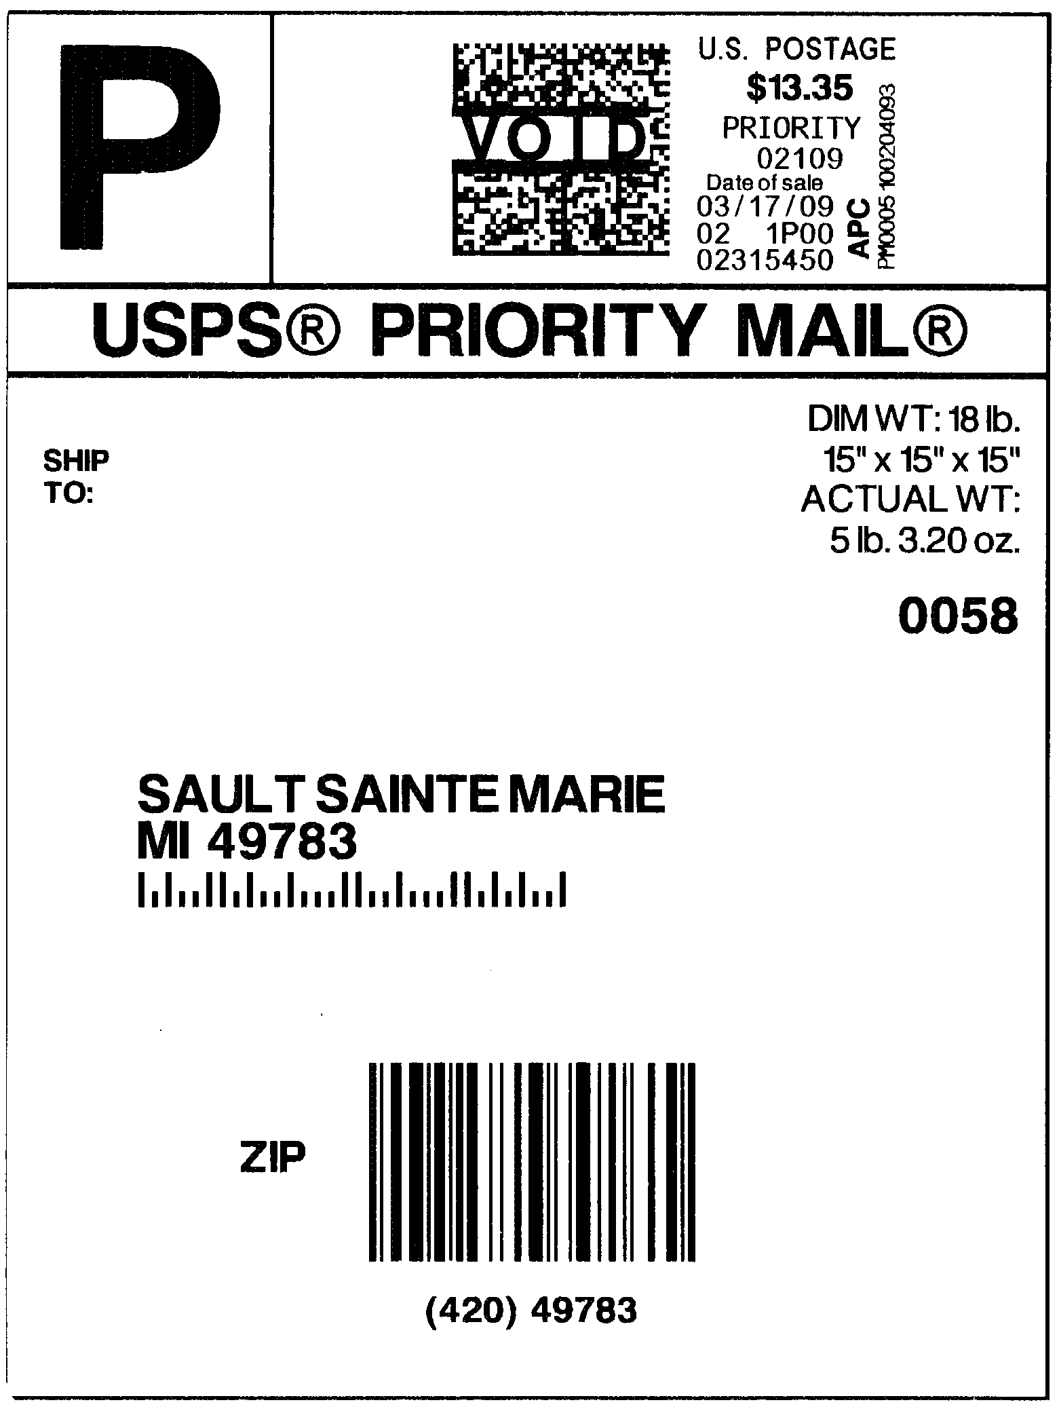
1001
0002

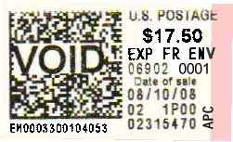
0002

Example of PC Postage (WebTools)
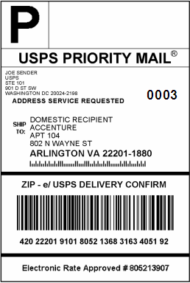
0002

Example of IRT PVI Label
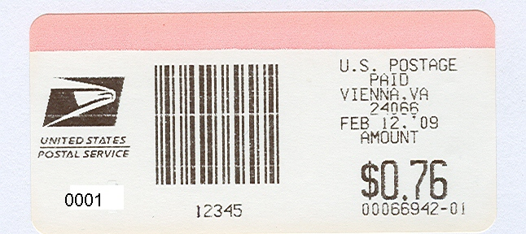
0002
$12.25
00066942-01

Example of Contract Postal Unit (CPU) Retail Distribution Code
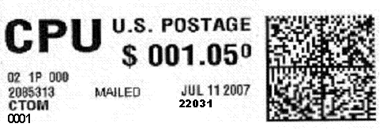
0002
$ 012.25

Example of Click-N-Ship (CNS) Express Mail
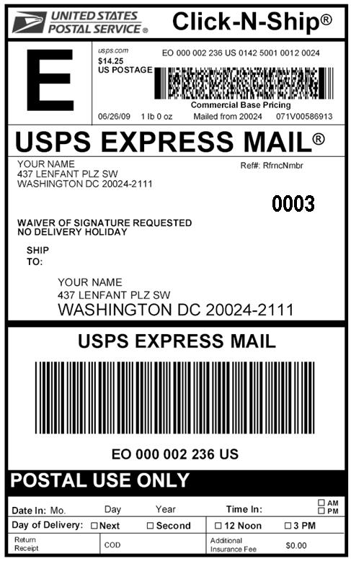
0007

Example of Click-N-Ship (CNS) Priority Mail
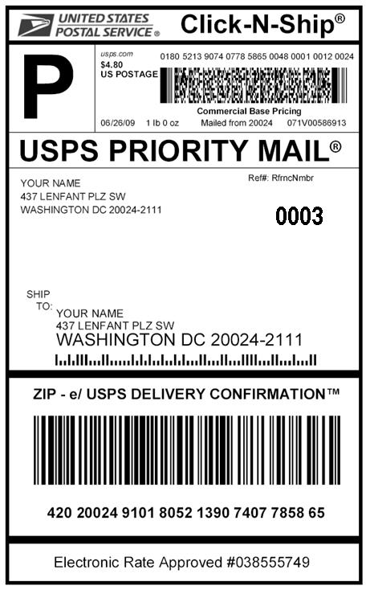
0005
SERVICE TALK #3
Mail Prep and Dispatch

Target Audience – Retail Associates and Clerks

Mail Preparation and Dispatch

District and local mail preparation guidelines should be updated to reflect the newly established Retail Distribution Codes (RDCs). Small offices, defined as those units below level 18, will make separations according to established District Mail Prep guidelines. Nationally, offices greater than level 18 are required to separate mail based upon the RDCs. All RDC separations will be clearly identified with a standardized placard indicating container contents.

Level 18 offices and above will dispatch individual RDC separations in rolling stock unless containers are less than ¼ full, at which time contents may be placed in flat tubs and dispatched in a mixed container using the 99 placard. Any time flat tubs are used to containerize RDC separations, each tub must be identified with the appropriate placard affixed to the individual tub.

With the exception of large parcels, products will not be mixed in rolling stock unless placed in identified flat tubs labeled with placards and placed in a container labeled as mixed. Do not affix placards to large parcels.

The All Purpose Container (APC) is the preferred container for dispatch of flat tubs and letter trays, with all attached placards or tray labels facing toward the front of the APC and the appropriate placard attached to the APC.

Standardized placards which identify the origin office will be utilized for all separations dispatched to the plant. A round stamp is the preferred method of origin identification.

Proposed Carrier Breakdowns for Offices Level 18 and Above:

Express Mail, Priority Mail, and Package Service packages:
- Required separations for Retail Distribution Codes (RDC) 00 – 07, 99 which will be incorporated into the Local Mail Preparation Guidelines.

Letters and Flats (RDC 00):
- Metered lettered mail – Trays
- Stamped letter mail – Trays
- Loose stamped and meter letters into a hamper.
- Metered and Stamped Flats - Flat Tubs
- Netflix – Flat Tubs

NOTE: For rural carriers, Part 412.2 of the Rural Carrier Duties and Responsibilities Handbook PO-603 requires that rural carriers are to “face and deposit mail in the location designated by your postmaster or supervisor”. Compensation is provided for facing and depositing mail. Management shall not require rural carriers to deposit mail into more than two designated locations. A location is defined as the tray or tub the mail is deposited into. For the parcels that meet the rural carrier definition (over 2 lbs) the location required to deposit these pieces would not be considered an additional separation or location. This would apply to most RDC separations.

The exception here is if more separations existed during the 2009 rural mail count and carriers were compensated with actual time during the count. Otherwise, rural carriers should adhere to the above until the next count when RDC separations are fully implemented.

Managers, Post Office Operations (POOMs) will verify unit separations are in place when visiting designated units.
SERVICE TALK # 4
Missent Mail

Target Audience – Back-Office Clerks

Missent mail is mail sent to the wrong delivery unit, station, or branch. Identifying and segregating missent mail from the normal mailstream is one of the most important elements in improving mail service.

The clerk must identify and return missent mail to the P&DC/F to be incorporated into the appropriate operation. The label on each missent mail tray must include the following information:

Missent Mail Tray Label
[NAME OF] P&D CENTER/FACILITY
MISSENT MAIL ALL CLASSES
[FROM CITY AND STATE]

Once the missent tray has been labeled, the delivery unit must use a missent mail facing placard to return the missent mail to the P&DC/F. This placard must include the following information taped to the top of the mail tray sleeve:

a. Identity of the Post Office, station, or branch
b. Date
c. Employee’s initials

After preparing the missent mail trays, dispatch them to the P&DC/F in containers on the next available transportation. For full trays of missent mail that were properly tray labeled and received in error, do not remove the tray label. Remove the tray label only if the tray label is incorrect. In both cases, apply the missent mail facing placard to the top of the sleeve and return the mail to the P&DC/Fs on the next available transportation.

In certain locations, the volume of missent mail may warrant a separate, larger container. If using an APC or hamper, properly identify the mail with a missent mail facing placard placed on the outside of the container. For smaller volumes, properly label the missent mail
trays and immediately dispatch them on the next available transportation.

In accordance with Management Instruction PO-420-2008-1, Associate Offices are to identify missent mail and separate it from loop mail by using missent mail placard 240M and return it to the processing center to be incorporated into the appropriate operation.

Attached is a Missent Placard 240.

MISSENT
MAIL

THIS MAIL MUST BE
REWORKED AND/OR
DISPATCHED TO THE
CORRECT FACILITY

FROM________________ TO_______________

Placard 240, March 2008 DATE_________________

SERVICE TALK # 5
Parcel Return Service (PRS) &
Non-Machinable Outsides (NMOs)

Target Audience – Retail Associates and Clerks

Parcel Return Service (PRS)

Parcel Return Service (PRS) mail destined to be picked up at the local Return Delivery Unit (RDU) must be maintained at the retail unit to be picked up by the customer. Parcel Return Service mail destined to be picked up at an NDC outside of the local RDU is to be dispatched to either Tier 1 or Tier 2 based on the retail placards indicating ZIP Code 569 or the ZIP range where 569 will be sorted.

Retail Associates duties
- Look for parcels with 569 ZIP Code
- Ask HAZMAT question if presented at the retail counter
- Ensure that no POS/IRT transaction is performed (no weighing, rating, zero PVI)
- Only one Special Service is allowed (Certificate of Mailing)
- A non-revenue transaction should be entered
- Retail Associates should not scan any PRS parcels
- Scanning will be done by back office personnel
- Deposit PRS parcels in a designated container

Specific instructions for handling Parcel Return Service Parcels can be found in Appendix D.

Non-Machinable Outsides (NMOs)

Non-Machinable Outsides (NMOs) are to be placed in a mixed container labeled as 99 - MIXED (not a specific RDC holdout). An outside parcel is a parcel that exceeds any of the maximum dimensions for a machinable parcel (17” Height, 17” Width, 34” Length).

NMOs could have different RDCs. However, if the parcel exceeds any of the above dimensions it is to be treated as an NMO and dispatched in a mixed container labeled as 99 – MIXED (see sample retail placard for 99 – Mixed).

Currently HQ Retail Operations is evaluating the use of a Non-Machinable sticker to be applied at the window next to the PVI label.

SERVICE TALK #6
Mail Prep and Dispatch

Target Audience – Carriers and Back-Office Clerks

Handling of packages brought back by carriers from the street

District and local mail preparation guidelines should be updated to reflect the newly established Retail Distribution Codes (RDCs). Small offices, defined as those units below level 18, will make separations according to established District Mail Prep guidelines. Nationally, offices greater than level 18 are required to separate mail based upon the RDCs. All RDC separations will be clearly identified with a standardized placard indicating container contents.

Packages picked up by carriers and returned to units will be consolidated in the appropriate separation with packages accepted across the retail counter prior to dispatch in the back office. Express is sacked along with those packages accepted at retail and dispatched appropriately.

In cases where large numbers of packages are received and there is insufficient time for separation prior to scheduled dispatch, parcels may be dispatched in a mixed container, with 99 placard attached.

For carrier units that have no retail window, local mail preparation guidelines will be followed, including the minimum national requirements for RDC separations.

NOTE: For rural carriers Part 412.2 of the Rural Carrier Duties and Responsibilities Handbook PO-603 requires that rural carriers are to “face and deposit mail in the location designated by your postmaster or supervisor”. Compensation is provided for facing and depositing mail. Management shall not require rural carriers to deposit mail into more than two designated locations. A location is defined as the tray or tub the mail is deposited into. For the parcels that meet the rural carrier definition (over 2 lbs) the location required to deposit these pieces would not be considered an additional separation or location. This would apply to most RDC separations.

The exception here is if more separations existed during the 2009 rural mail count and carriers were compensated with actual time during the count. Otherwise, rural carriers should adhere to the above until the next count and RDC separations are fully implemented.

Reference Materials

Retail Operations website

The Retail Operations website is located at:

http://blue.usps.gov/retail/L2Workforce_F4.htm

Materials related to the NDC Activations are:

    - POS PVI Poster & RDCs
    - FAQs
    - POS Offices – 18 & above
    - POS Software R36 Release – Deployment Schedule
    - Readiness Assessment Checklist & Instructions

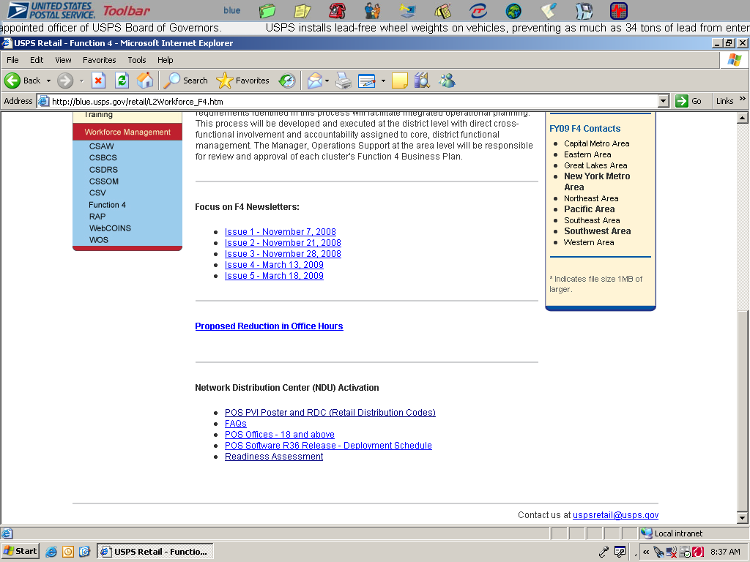

Visual Aid
See below for a poster than can be displayed with Retail Distribution Codes.



SEPARATIONS BASED ON LAST 2 DIGITS ON POS ONE PVI LABEL
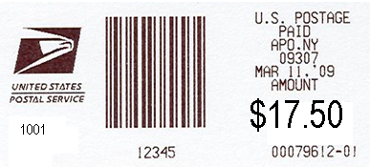
1002
Routing Barcode
Originating
City, State,
ZIP Code

Date
Retail Distribution
Code
1001
Postage Rate

Destinating ZIP Code
POS Terminal Number- Clerk ID
- No Code FCM Letters, Flats and SPRs

(Maintain current process for mail separation)
- Local NDC Packages

- Network NDC Packages

- Network NDC Packages (used for directional dispatch)

- Priority Parcel - Network

- Overnight Parcels & SPRs

- Priority Flats

- Express

Note: Local distribution codes begin at “20”

Sample Retail Distribution Placard

Readiness Assessment Checklist

The readiness assessment checklist must be completed at least one week prior to activation or as specified by the District Coordinator. The Postmaster or Station Manager is responsible for completing the checklist, and providing it to the District NDC Coordinator.

The POOM must also be involved in ensuring the checklist is completed and that individual offices, stations, and branches are complying with these mail preparation guidelines.

Use the sample form to record the names of employees who received training (questions # 1 and 2 on the readiness assessment checklist).

APPENDIX A - Retail Distribution Code (RDC) Request Process

The retail distribution code change request form should be completed by the Area coordinator and submitted to HQ Network Integration Support via HQLabelList@usps.gov. Signature and submission of the change request form results in area acknowledgement of work hour impacts that may be associated at the Post Office, Plant or NDC level. Retail Distribution Code (RDC) changes may also be initiated by HQ in support of key initiatives and will be coordinated with the Areas.

Upon receipt of the justification form, Network Integration Support will coordinate the review board evaluation of the proposal to ensure the request is in alignment with network and retail operations policies and that sufficient volume exists to warrant the separations. The RDC Review Board is composed of representatives from the following groups:

- Network Development & Support
- Logistics (Transportation Field Support)
- Processing Operations
- Retail Operations

After completing the review, notification of a decision will be provided to the Area Manager Operations Support (MOS), Area coordinator, Area Post Office Operations Manager (POOM) and Area Manager of In-Plant Support (MIPS).

The approved RDC codes will be aligned with the start of a Postal quarter. The timeline for FY2009 submissions are outlined below:

The following forms must be completed as part of the request process.

APPENDIX B – Container Placard Examples – Dispatched from Retail Units

Preparation of mail at the retail unit is essential to the success of the new network. The following are examples of mail prep from a retail unit.

Example #1 – Volume warrants a full container: the correct placard is affixed to the container, and mail is sorted by the RDC into that container.
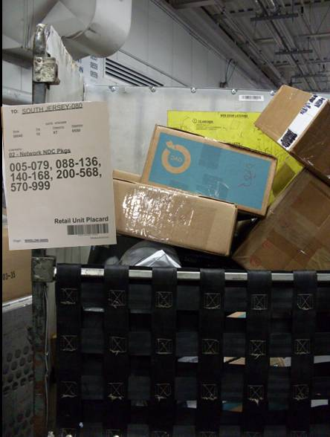
All packages with RDC 02 are sorted to this container; container is filled to the top before replacing it with a new container.

Example #2 – Volume does not warrant a full container: flat tubs are used for individual RDCs and placards are affixed to or laid on top of the flat tub. Do not tape placards to individual parcels.

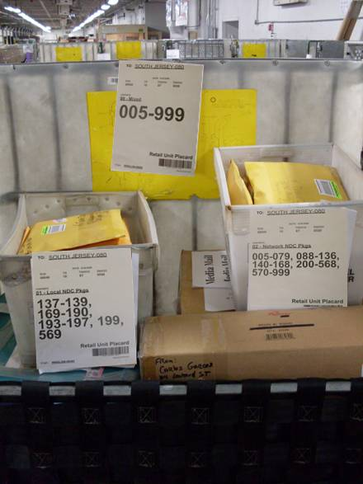
“99-Mixed”: mixed placard must be attached to the larger container.
Flat tubs with placards for RDC 01 and RDC 02

Example #3 – Volume does not warrant a full container: a container with a shelf is used to separate multiple RDCs.
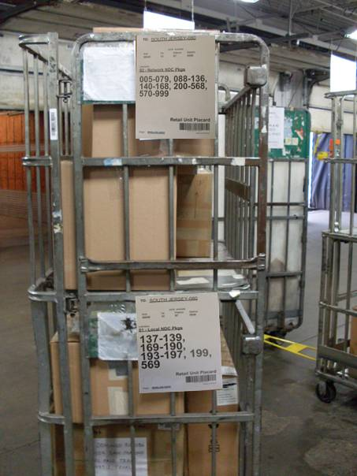

Example #4 – Failure to separate the mail

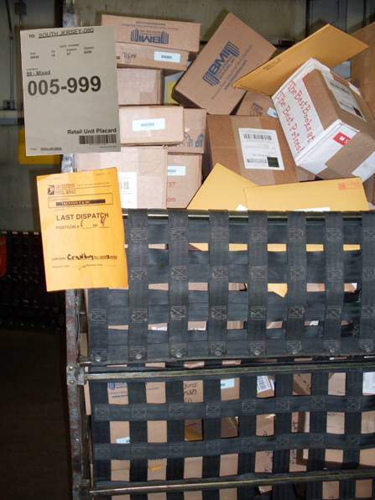

Example #5 – Incorrect placards: mail separated properly must have the appropriate placard from MTEL attached.

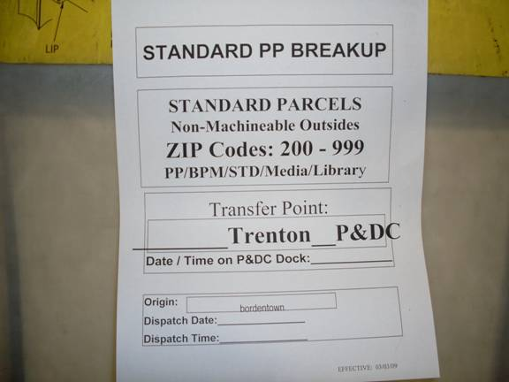

APPENDIX C – Parcel Return Service

PARCEL RETURN SERVICE (PRS) RETURN DELIVERY UNIT (RDU)

Identifying PRS Packages – Sample label

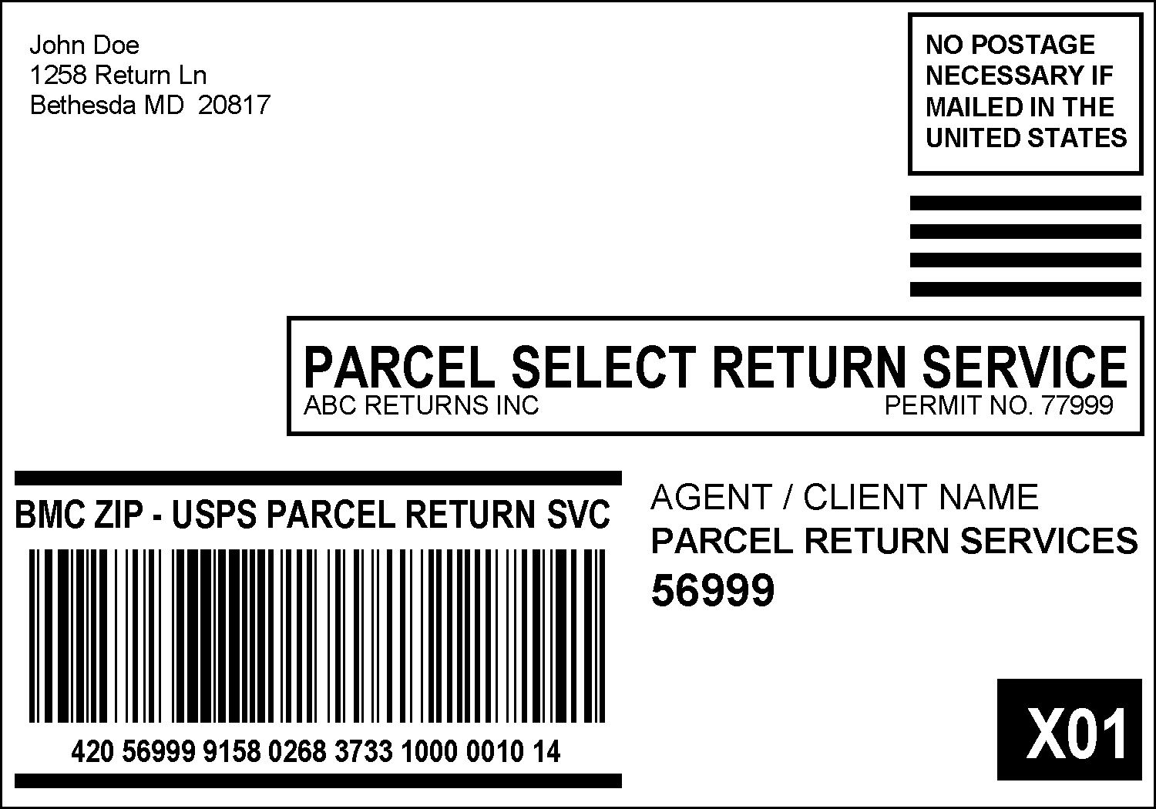

Identify PRS Parcels
- Look for parcels with 569 unique zip
- Parcel Select RTV SVC on label
- Alpha character – (number following alpha will vary and is not relevant to USPS)

Identify PRS Parcels in the Following Locations
- Retail Operations
- Carrier Routes
- Collection Boxes

Retail Associates duties
- Ask HAZMAT question if presented at the Retail counter.
- Ensure that no POS/IRT transaction is performed (no weighing, rating, zero PVI)
- Only one Special Service is allowed (Certificate of Mailing).
- A non-revenue transaction should be entered.
- Retail Associates should not scan any PRS parcels.
- Scanning will be done by back office personnel.
- Deposit PRS parcels in a designated container.

Carrier duties
- Separate all PRS parcels from other collection mail.
- Upon return to unit, deposit all PRS parcels in the designated PRS container.
- Letter carriers should not scan any PRS parcels collected.
Collector’s duties
- Upon return to the unit, deposit PRS packages in the designated PRS container.
- Collectors should not scan any PRS parcels collected.
NOTE: For those collection routes not returning to the RDU, follow local policy.
PARCEL RETURN SERVICE (PRS) RETURN DELIVERY UNIT (RDU)

Back Office Employee
Scanning / Dispatch Instructions

Scan 1 Returns Mode - Option A > Available for Pickup - Option 1
Generating Payment for USPS
- Retrieve PRS parcels from designated PRS containers.
- Separate PRS packages by 569 unique ZIP Code. Any PRS parcels not scheduled for pick up at your office should be dispatched to either Tier 1 or Tier 2 based on the destination ZIP range indicated for 569 on the Placard.
- Perform the following on PRS parcels scheduled to be picked up at your facility:
  - In Main Options on the handheld scanner, select “Returns Mode” (Option A).
  - Scan PRS barcode
  - Select “Available for Pickup” (Option 1)
  - Date each package
  - Place scanned parcels in designated area for Agent pickup.
  - Dock the scanner by the end of the day.

Scan 2 Returns Mode - Option A > Picked Up by Agent - Option 2
Returning Parcels to the Merchant/Agent
- Ensure standing delivery order PS Form 3801 is on file and contains signature of the Agent.
- When Agent arrives:
  - In Main Options on the handheld scanner, select “Returns Mode” (Option A).
  - Scan barcode of all PRS packages
  - Select “Picked Up by Agent” (Option 2)
  - Complete and retain PRS Dispatch Log, PS Form 6354.
  - Parcels may be returned to the merchant/agent after scanning and log is complete.
  - DO NOT scan packages both “Picked Up by Agent” and “Returned to Sender – Not Picked Up

On the rare occasion that you would receive an Oversize Parcel:

Oversize Parcels Returns Mode - Option A > Random Sampling - Option 2
- Identify and set aside any oversize parcels (exceeding 108” but not more than 130” in combined length + girth) for additional scanning steps.
- In Main Options on the handheld scanner, select “Returns Mode” (Option A).
  - Select “Random Sampling” (Option 2)
  - Scan barcode
  - Is parcel oversized? – Select “Yes” (Option 1)
  - Weight entry screen – Press enter to bypass
  - Place in designated area for Agent pickup.

PARCEL RETURN SERVICE (PRS) RETURN DELIVERY UNIT (RDU)

Back Office Employee
Missed Pickup Instructions

Parcels Not Picked Up by Agent
If a pickup does not occur, contact the following:
  - Scanning Coordinator
  - Scanning coordinator will contact BSN, Area, HQ and customer
- Hold the packages until you receive dispatch instructions from the Scanning Coordinator
- If instructed to return packages to the NDC
  - Only return packages with dates over 4 days old (see 96-hour Rule below)
  - In Main Options on the handheld scanner, select “Returns Mode” (Option A).
  - Scan barcode
  - Select “Returned to Sender – Not Picked Up” (Option 3)
  - Complete the PRS Dispatch Log indicating dispatch of the packages to the NDC
  - Dispatch the selected packages to the NDC

96-Hour Rule – Does Not Include Sundays and Holidays
- Captured on Monday would not be sent to the NDC until Saturday
- Captured on Tuesday would not be sent to the NDC until the following Monday
- Captured on Wednesday would not be sent to the NDC until the following Tuesday
- Captured on Thursday would not be sent to the NDC until the following Wednesday
- Captured on Friday would not be sent to the NDC until the following Thursday
- Captured on Saturday would not be sent to the NDC until the following Friday

(The above would all shift during a week with a holiday)

APPENDIX D – Frequently Asked Questions

- What is a Retail Distribution Code?
This is a two digit number that will be used to sort to designated separations

- When are the software changes going to be made to postage generating systems?
POS PVI – April 2009
IRT PVI – July 2009
APC IBI – July 2009
APC SSL (Standard Shipping Label) – July 2009
CARS – July 2009
PC Postage – July 2009
Click N Ship – July 2009

- What are the font sizes that will be applied to the postage labels?
POS PVI – Font size 8
IRT PVI – Font size 8
APC IBI – Font size 8
APC SSL (Standard Shipping Label) – Font size 14 BOLD
CARS – Font size 8
PC Postage - Font size 14 BOLD
Click N Ship - Font size 14 BOLD

- How big is the CARS label?
The current label is 4" wide by 1.5" inches tall.

- Can the font size be increased?
In order to increase the font size of the PVI retail distribution code, it will require an upgrade to the PVI firmware.

- Will there be any type of identifier on the PVI that will allow us to determine which office and which clerk generated and sorted the package?
Yes. On the PVI label, the following appear – originating ZIP Code, POS terminal number and clerk ID.

- What is the frequency of updates for the ZIP Code tables in the Retail systems?
Quarterly

- What is the NDC Implementation schedule for Phases 2 through 4?
Phase 2 implementation is scheduled to begin of the Network Distribution Center (NDC) concept August 10, Phase 3 will begin September 14, and Phase 4 will begin on October 19.

- What does the number below the postage on the PVI (e.g., 00027469-09) represent?
It is a PVI serial number. It identifies the machine that printed the postage label. The two digits after the dash is the clerk ID number. For financial audit trail, this information allows the Postal Service to know the clerk and PVI machine that printed the postage.

- How are the new labels affecting the barcodes on the PVI label?
There is no impact; they are still the same.

- What are the craft implications of the separations numbers on the PVI labels?
If the sortation is occurring in the retail operation for packages that are accepted by a retail associate, the efficient practice would be to have the retail associate finalize the sort with their initial handling. If the sortation is occurring from packages returned from the street by carriers, the efficient practice would be to have the carriers finalize the sort with their handling and not to incorporate a second handling by a mailhandler. If the carriers do not perform the sortation, then a mailhandler would most likely be assigned this task instead of a clerk (assuming a mailhandler is assigned in the post office).

- Can you explore if reverse printing can be done on the PVI label to make the RDC code more distinct?
The program office has evaluated and reverse printing cannot be done.

