“The Perfect Retail Transaction”
1. ☺and greet the customer!

2. Does this package contain anything Liquid, Fragile, Perishable, or Potentially Hazardous?”

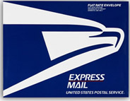
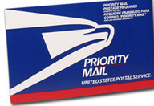
3. Would you like to send this Express Mail, a guaranteed service which includes $100 worth of insurance?
OR Would you like to send this Priority Mail a 2 to 3 day service?

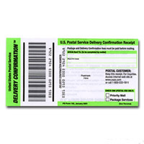
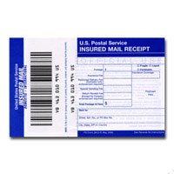
4. How much Insurance would you like to purchase to protect your package against loss or damage?
AND
Will you need Delivery Confirmation to confirm delivery of your package?
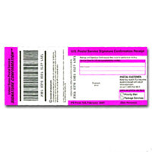
OR Would you like Signature Confirmation which provides confirmation of delivery date/time & a copy of the recipient signature today?

5. Suggest an additional item. Do you need any stamps today?
Would you like to purchase any of our Ready Post packaging supplies, philatelic items or OLRP products?

6. Thank the customer for their business & hand them their receipt.

“The Perfect Retail Transaction”
1. ☺and greet the customer!

2. Does this package contain anything Liquid, Fragile, Perishable, or Potentially Hazardous?”

3. Would you like to send this Express Mail, a guaranteed service which includes $100 worth of insurance?
OR Would you like to send this Priority Mail a 2 to 3 day service?

4. How much Insurance would you like to purchase to protect your package against loss or damage?
AND
Will you need Delivery Confirmation to confirm delivery of your package?
OR Would you like Signature Confirmation which provides confirmation of delivery date/time & a copy of the recipient signature today?

5. Suggest an additional item. Do you need any stamps today?
Would you like to purchase any of our Ready Post packaging supplies, philatelic items or OLRP products?

6. Thank the customer for their business & hand them their receipt.

