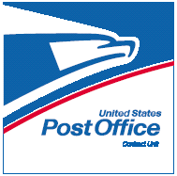
CPU
Express Mail Procedures
Saturday Acceptance of Express Mail

Acceptance times on Saturday are from when you open to your last collection time. Do not accept any Express Mail outside of these hours and NEVER ON SUNDAYS or HOLIDAYS. Refer any customers wanting to mail Express Mail outside of your acceptance hours to the closest Post Office Station.

Iowa destination ZIP Codes – use the list at the front of the Express Mail Directory to see if the ZIP Code/Town is listed for Sunday delivery. If the ZIP Code/Town is listed, Sunday delivery is available to that destination and the item should be guaranteed Next Day by 3PM. If the ZIP Code/Town is NOT on the list the item MUST be guaranteed 2nd Day by 3PM – MONDAY

Out of State destination ZIP Codes – accepted on a Saturday should be guaranteed for the 2nd Delivery Day, which would be TUESDAY. Mark the Second* box in the Day of Delivery section on the Express Mail label. However, in addition to checking the Day of Delivery block and the time of delivery (12 Noon or 3PM) block, you must now also record the actual expected delivery date on the label for all "2nd Delivery Day" commitments. For 2nd Delivery Day commitments ONLY, record the month and day of expected delivery (such as 2/13/07) on the Express Mail label in the same block as the 12 Noon and 3PM options.

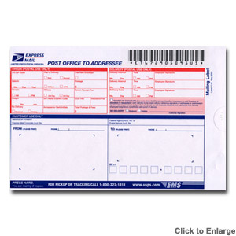These same rules apply to Express Mail accepted the day before a Holiday.

*New labels dated March 2004 have a 2nd Del. Day box and a scheduled date of Delivery section, the 2nd Del Day box should be checked and actual date written in.

