Delivery Options  International Delivery Services from the U.S. Postal Service Service | Pricing | Delivery* | Features
Global Express Guaranteed®  (GXG) Reliable, date-certain shipping to over 190 countries.  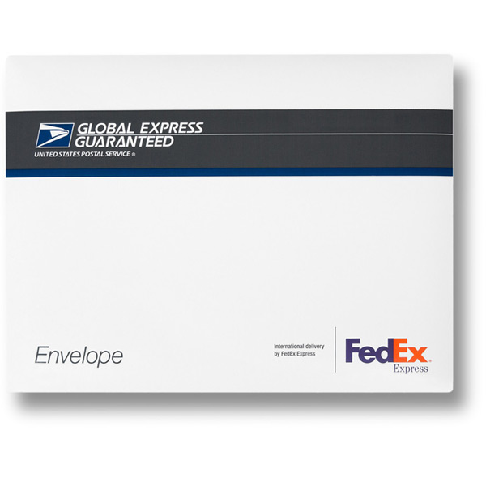 | Starts at $28.50 | 1-3 business days | Money Back Delivery Guarantee Tracking Available Free $100 Insurance Free Packaging & Carrier Pickup 10% Online Discount.
Express Mail International®(EMI) Reliable, expedited service l to over 190 countries. Now available with day-certain delivery to select destinations.  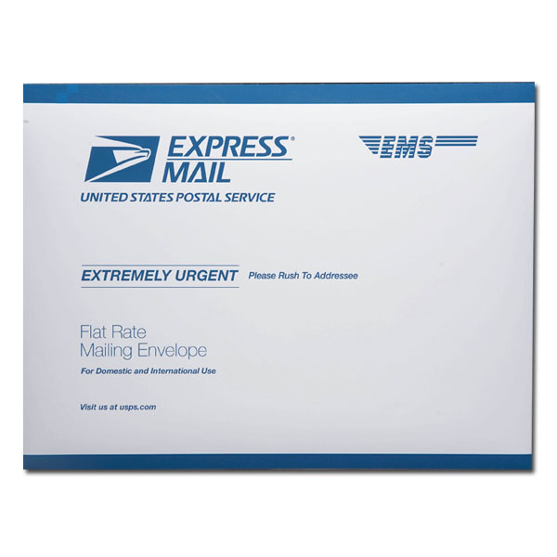 | Starts at $22.00 | 3-5 business days | Guaranteed to Select Destinations Tracking Available Free $100 Insurance Flat Rate Envelope Free Packaging & Carrier Pickup 8% Online Discount
Priority Mail® International (PMI) Reliable, priority handling to over 190 countries worldwide.  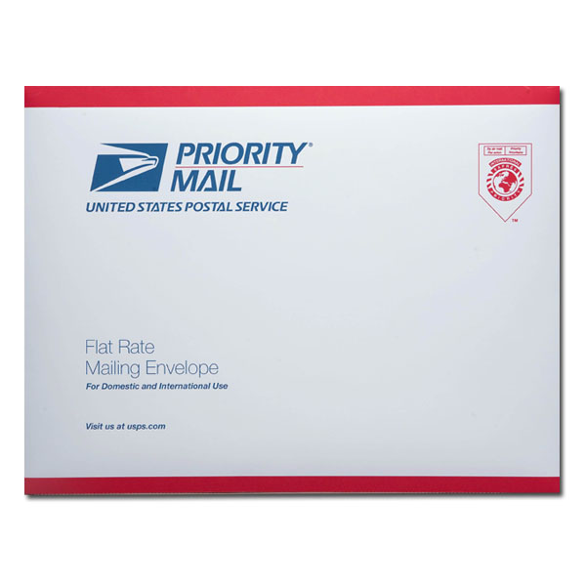 | Starts at $16.00 | 6-10 business days | Tracking to Major Destinations  Flat Rate Envelope and Flat Rate Boxes Free Limited Insurance Registered Mail w/o Insurance (flat rate envelope only)  Free Packaging & Carrier Pickup 5% Online Discounts
First-Class Mail® International | Starts at $.69 | varies by destination

