LABELS FOR MAIL PIECES
The labels and stickers shown here must be ordered from the USPS MDC. Locally-designed or produced labels are not permitted.
Proper placement of these stickers is described in the AvSec Unit section.

CUSTOMER NOTIFICATION LABEL DDD-2

SURFACE TRANSPORTATION ONLY LABEL 127

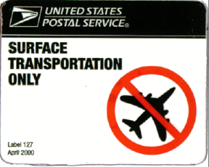

SURFACE TRANSPORTATION ONLY

LABELS FOR MAIL RECEPTACLES AND LOBBY DROPS

The following is the mailbox/kiosk/lobby drop decal or sticker. It must be affixed to every mailbox, collection receptacle, lobby drop, or kiosk, including Express Mail collection boxes and Collection Box Units (CBUs) with public access as illustrated below.

CUSTOMER NOTIFICATION LABEL DDD-1

USPS Materiel Distribution Center ordering information - Phone (800) 332-0317:
DECDDD1 with an NSN 7690040006662
DECDDD1S (Spanish) with an NSN 7690040006663

NOTE: The Customer Notification Label DDD-3 (blue background with white lettering) is acceptable for use only on lobby drops.

CUSTOMER NOTIFICATION LABEL DDD-3

Application instructions:

Following illustrates the only acceptable application locations for the DDD-1 label on all collection boxes. Locally made reproductions of this sticker are not acceptable. These labels must be ordered from the USPS MDC.

Place Customer Notification label (DDD-1) on all collection boxes immediately above the pull-down door where customers deposit mail.

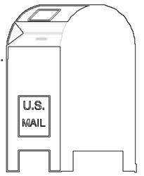
Center the label on the box with the bottom edge of the label parallel with the bottom of the hood to the door.

The label must be clearly visible to customers when they deposit mail in the receptacle.

For snorkel collection boxes, place the Customer Notification label (DDD-1) immediately above the pull-down door.

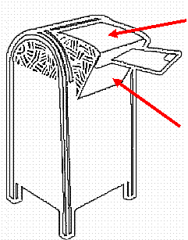

Also place additional DDD-1 label immediately above and immediately below the deposit slot on the snorkel side of the box.

For Lobby Drops, CBUs with public access, or any other type of collection receptacle, place the DDD-1 Customer Notification label immediately above the mail drop slot.

NOTE: The DDD-3 label is being phase out, and will be replaced by the DDD-1. As illegible DDD-3 labels are discovered, they should be replaced with the DDD-1. At this time, it is not necessary to replace legible DDD-3 labels currently in use with a DDD-1.

The placards shown may be reproduced locally as needed, but may not be altered as to content, appearance or size. All sections of the placard must be completed at the time the mail piece is accepted or dispatched. These placards are to be placed on all Target Mail and Known Customer Mail containers as appropriate. The program requires all Target Mail and Known Customer Mail to be isolated, containerized and placarded. Sacks and/or pouches are not acceptable for containerization. If the mail piece is too large to be placed in a suitable container for transportation, affix the appropriate placard to the mail piece completely covering the destination address.

CONTAINER CONTENTS
TARGET MAIL

TO:__________________

EXPEDITE TO
DESIGNATED AV SEC UNIT

ORIGIN: ___________________
ZIP:_________

PREPARER’S INITIALS:___DATE:____/_____/___
□POTENTIAL □VERIFIED BY:___
CONTAINER CONTENTS
KNOWN CUSTOMER MAIL

TO:_______________

EXPEDITE TO
DESIGNATED AV SEC UNIT

ORIGIN: _________________________

ZIP:_______

PREPARER’S INITIALS:____DATE:__/__/__

CONTAINER CONTENTS
TARGET
MAIL

TO:___________

EXPEDITE TO
DESIGNATED AV SEC UNIT

FROM
ORIGIN: ______ ZIP: ______

Preparer’s initials: ____
date: ___/___/___

□Potential TARGET MAIL
□verified TM :____

CONTAINER CONTENTS
TARGET MAIL

TO:___________

EXPEDITE TO
DESIGNATED AV SEC UNIT

FROM
ORIGIN: ______ ZIP: ______

Preparer’s initials: ____
date: ___/___/___

□Potential TARGET MAIL
□verified TM :____

KNOWN CUSTOMER MAIL

TO:___________

EXPEDITE TO
DESIGNATED AV SEC UNIT

FROM

ORIGIN: ______ ZIP: ______

Preparer’s initials: ____

date: ___/___/___

KNOWN CUSTOMER MAIL

TO:___________

EXPEDITE TO
DESIGNATED AV SEC UNIT

FROM

ORIGIN: ______ ZIP: ______

Preparer’s initials: ____

date: ___/___/___

