Thread: Logan/Smyth and the Mystery of the Ring Knife
- Thread Tools

- 09-10-2011 10:02 PM #1

Sharp Phil

The Martialist
Join Date
Feb 2002
Location
PhilElmore.com
Posts
7,513

Logan/Smyth and the Mystery of the Ring Knife


Sponsored Ad
Remove ads and support BladeForums.com!
It all started when a friend of mine gave me a curious little knife he found at a flea market. Shaped like a ring, it was, he was told, a “paperboy knife,” used decades ago by newspapermen to cut the twine on bales of newspapers. A little searching on eBay revealed that knives of this type are also called “postal knives.” The application seemed obvious enough. While wearing this knife on your finger, you could easily use it for packaging and cutting cord and string, yet there would be little danger of injury to the wearer.
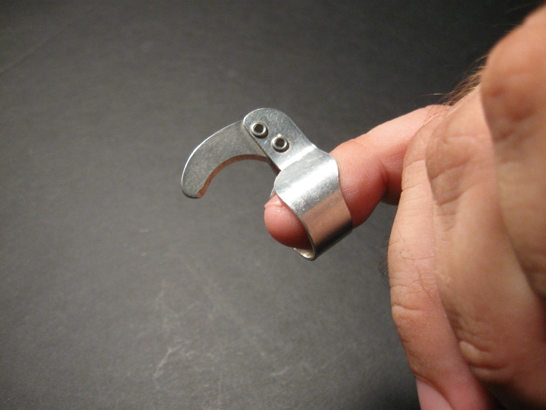
My sample bore a clue to its origin: the words “Logan Smyth” and the number “6.” The 6 I could interpret easily enough; the ring was roughly that size and just barely fit my pinky. “Logan Smyth” I took to be the manufacturer… but who was Logal Smyth, and were they still in business? How old was my knife likely to be?
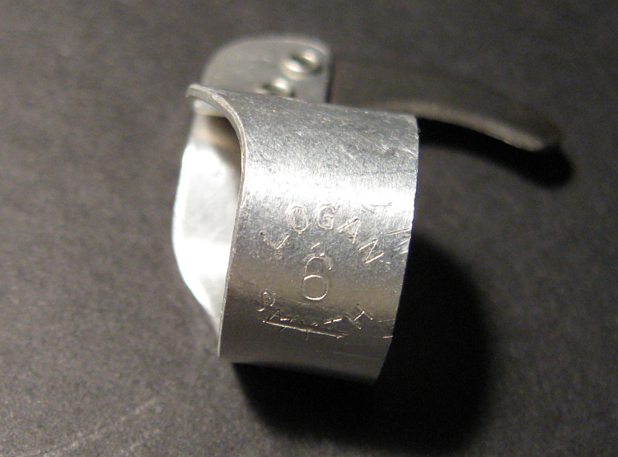
A query at the knife enthusiast bulletin board Bladeforums proved very interesting. No one could tell me much about Logan Smyth, but several participants identified my blade as a Handy Twine Knife. One collector even had a box of very old Handy Twine Knives, complete with documentation, and this included instructions for using the blades.
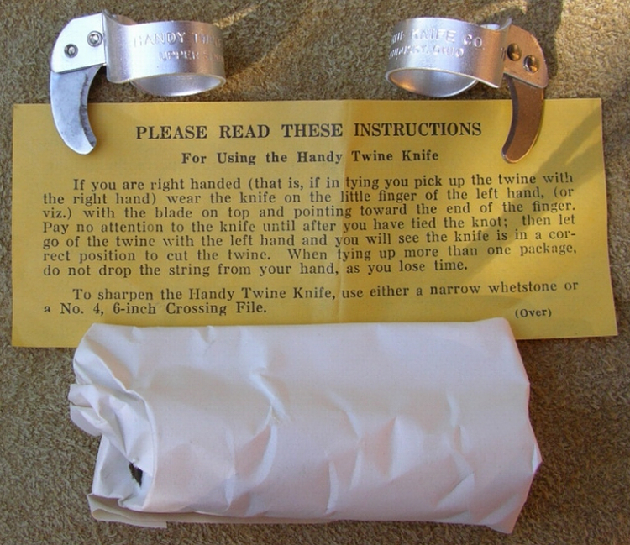
Photo courtesy of Roland Procter.
The Handy Twine Knife Company of Sandusky, Ohio, it turns out, has been in business for more than a hundred years. They have manufactured nothing but ring knives during all that time. “Our utility knives lead the industry,” their website asserts. “This ring-type knife can be used to cut twine, ribbon, plastic strapping, pallet wrap, tape, cardboard, even light gauge wire!” The company claims its little knives can even increase productivity while reducing “the risk of repetitive motion injuries.” The ring band is aluminum, while the blade is heat-treated steel held in place with nickel-plated brass rivets. The Handy Twine Knife Company also offers knives with polycarbonate plastic rings and offers an FDA-approved model for use in food processing (such as meat packing).
According to the company’s history page, the knife was invented by a postal worker named James R. Caldwell in the late 1800s. Frustrated at his inability to “keep track of” his pocket knife while sorting mail for transportation by rail, he attached the blade of his knife to a copper band bent around his finger. (The Handy Twine Knife Company says this original knife is now on display at the Smithsonian Postal Museum.)
Caldwell is said to have founded Handy Twine shortly thereafter, to have recorded his first sale in 1904, and to have filed for a patent in 1910 (which was approved in 1912). But this begged the question: Where did “Logan Smyth” fit? The company was known to have manufactured, under contract to the US Government, some quantity of automatic MC-1 aircrew survival knives. Was Logan Smyth a subcontractor to the Handy Twine Knife Company?
I spoke with Eric Oldham, Handy Twine’s national sales manager. He was not familiar with Logan Smyth, but he verified that the knife in question was not made by his company — nor did Handy Twine label their ring knives the way my sample was badged, with the size number inside the text of the company name, arranged in a circular pattern.
To know more, I had to find someone who could tell me about Logan Smyth. Steven K. Dick of Tactical Knives magazine mentioned the company in his article on the MC-1. “…At various times,” he wrote, “the MC-1 was made on contract by Schrade Walden, Camillus Cutlery, and a mysterious company called “Logan/Smyth” that no one seems to know anything about. Schrade went under several years ago; Logan/Smyth seems to have disappeared right after their contract was completed…”
A call to Information for Venice, California (Logan/Smyth’s last known place of operation) yielded no listings for a company by that name in Venice or the surrounding area.
I then tried LinkedIn, the business networking website. There I found Michael Furey, who listed among his past positions President of Logan/Smyth Manufacturing. I managed to track him down through the phone tree for his current business, and was pleasantly surprised to find him very forthcoming once I explained what it was that I wanted.
Mr. Furey explained that his grandfather and a business partner owned the Bates File Manufacturing Company, one of the largest makers of manicure implements in the world. At one time, Bates File made over 175 different nail care products. The company also manufactured, for the United States Government, ring knives like my Logan Smyth sample.
Mr. Furey’s father was with Bates File until 1981 and was responsible for the tooling for the ring knives. It was in 1981 that he, with his son Michael, started Logan/Smyth manufacturing. “We took the ring knife contract away from Bates,” Michael Furey explained, “and kept it away from Bates because they couldn’t deliver the product in a timely fashion. We bid the contract to the General Services Administration in 1982 and held it until we closed in 2005.” While the Handy Twine Knife Company was making similar knives during this period, according to Mr. Furey, “the primary customer and the largest purchase of ring knives on the planet was the U.S. government.”
Of the Handy Twine Knife Company, Michael Furey said, “Handy Twine is a good company that makes a multitude of different knives. …I believe they primarily sold their ring knives to the newspaper industry for binding newspaper bundles.”
At the height of its production, Furey explained, Logan/Smyth Manufacturing “shipped 125,000 to 150,000 knives a month in five different sizes to the government. Size 6 was the smallest, while sizes 8, 9, 10, and 12 were the largest. The tens went to the military for the military postal service.” Logan/Smyth also made insulated drinkware, a myriad of nail care implements, and specialty items. None of its contributions to the knife industry are as well known as the MC-1 aircrew survival knife, however — nor has the association been free if controversy, however mild.
There has been a great deal of speculation online that Logan/Smyth lost the government contract to produce the MC-1, and that this may have contributed to the company’s demise. Neither assertion is true, according to Michael Furey. He disputes the claim that Logan/Smyth experienced quality issues in producing the MC-1.
“During our initial production run of the MC-1,” he said, “one order of 1600 knives came back. We had purchased a new grinding machine and, for the first run of the knives, we didn’t have the proper wheels in place, so we had a buffeting problem. We took those back and replaced them, but other than that, there were no problems. We built 17 major tools and 30 support tools in 60 days when we got the contract, and were shipping product in 90 days.”
What, then, ended Logan/Smyth’s association with the MC-1? “The MC-1 contract was terminated at the convenience of the government,” Furey told me. “It was the end of the Reagan era, and it was Regan who put the Buy American clause in the contract… Termination ‘for the convenience of the government’ was the legal term. It was because the budgets were getting slashed to pieces.”
The MC-1, as it turned out, was no easy knife to manufacture, either. “The MC-1 was primarily made to go in the rescue kit for every air crew,” Furey said, “but the knife was originally made in World War Two and they made no changes or adjustments to [the design] in the years after. There were materials in the original contract you couldn’t even purchase anymore, or that were prohibitvely difficult or expensive to get, like the nickel silver for the slide lock on the switchblade itself.”
Changing times and changing budgets ultimately saw the end of Logan/Smyth’s production of the ring knife, too. “The age of the Internet killed the need for the ring knife,” Furey explained. “We saw a down-tick in 2000 and 2001. The orders just dried up. The postal service is still getting creamed by the Internet. There’s less mail going out. This started back in 2000. They simply didn’t need the knives the way they used to. It wasn’t worth us even chasing the dies on the presses. We just stopped bidding.”
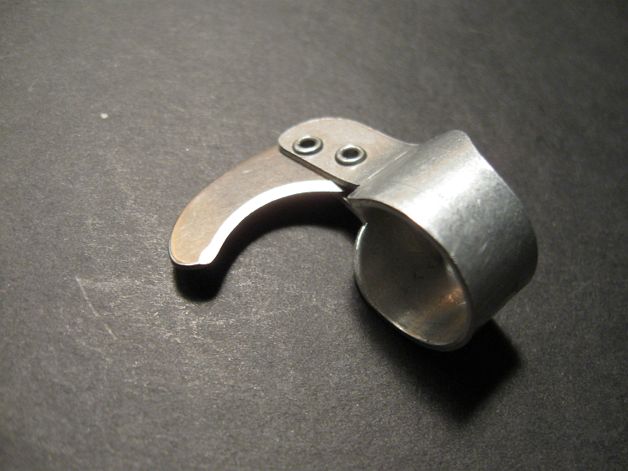
Logan/Smyth Manufacturing eventually closed in 2005 after the death of Michael Furey’s father and his mother’s subsequent illness. I was saddened to hear of Mr. Furey’s loss, but extremely grateful for the insight he provided concerning his company. Little about Logan/Smyth has been published online beyond speculation about its production of the MC-1, nor was it obvious to me initially whether the company was, in fact, out of business. While Michael Furey is a busy man with many business ventures underway, it is clear to me that Logan/Smyth and its little ring knives are a topic, and a memory, that brings him great satisfaction. Given that his family’s history is intertwined with that of Logan Smyth’s postal knives, there is a certain finality to his recollections of that time in his career.
“I was president of Logan Smyth from 1985 until it closed,” he said, before concluding our interview. “It was a great living for a lot of people. Now… Now I’m the last living member.”

