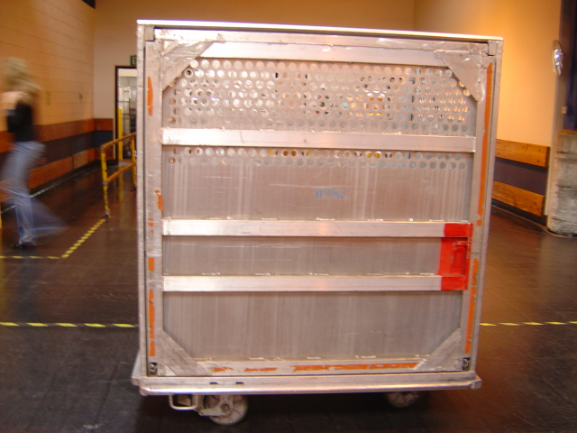  BMC/OTR  475 lbs  Max loaded weight 1,500 lbs  Max | 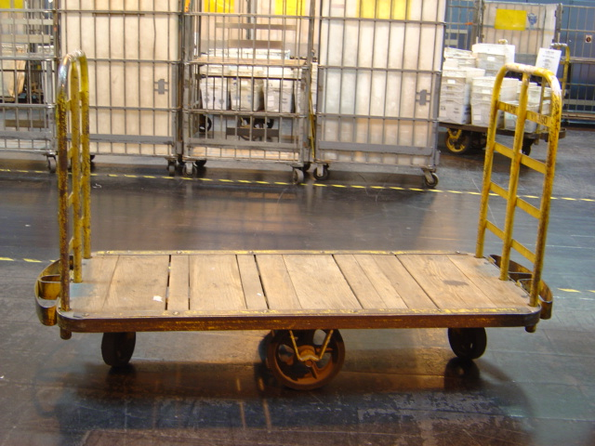  HAND TRUCK 290 lbs  Max loaded weight 3,000 lbs | 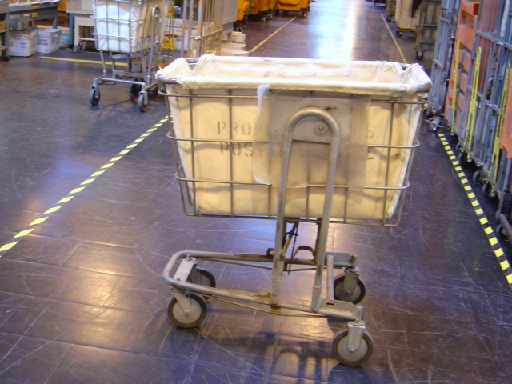  U-CART  80 lbs  Max loaded weight 120 lbs
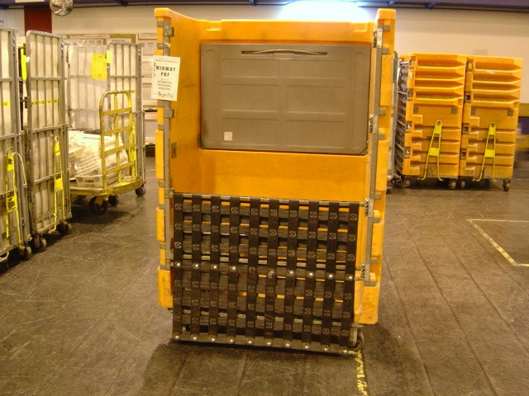  ORANGE APC/ERMC  260 lbs  Max loaded weight 1,200 lbs | 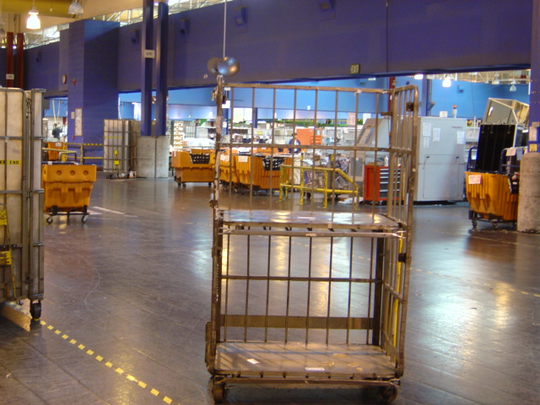  APC-GPMC  W/Shelves 272- W/O 242 lbs  Max loaded weight 1,200 lbs | 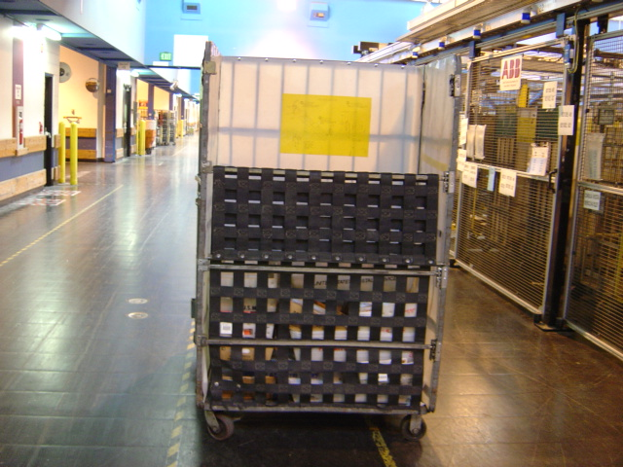  APC-ERMC  W/Insert 235 lbs W/O /209  Max loaded wt 1,200 lbs
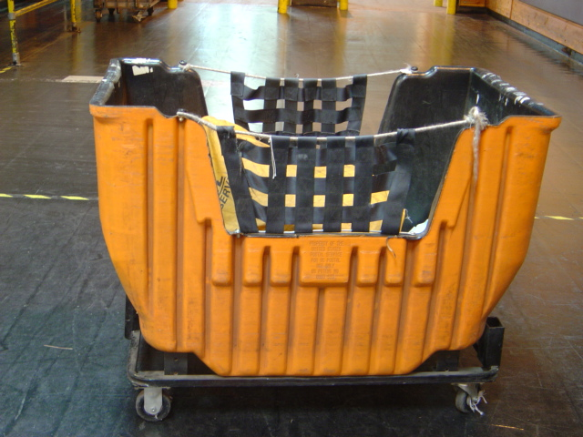  ORANGE HAMPER  82 lbs  Max loaded weight 1,200 lbs | 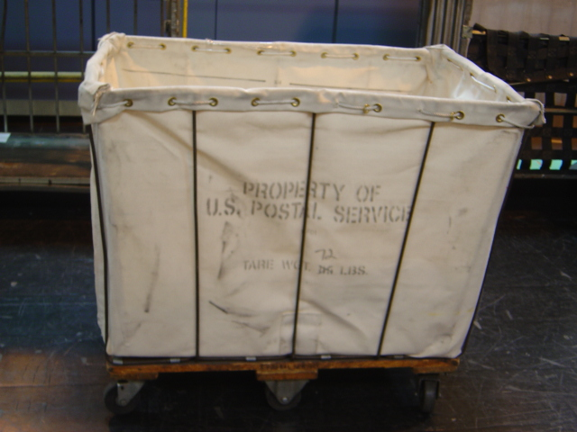  CANVAS HAMPER  LARGE 75 lbs  Max loaded weight 800 lbs | 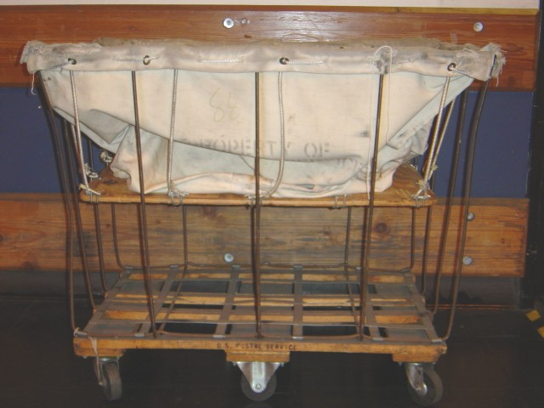  CANVAS HAMPER  Wooden Insert 85 lbs  Max loaded weight 800 lbs
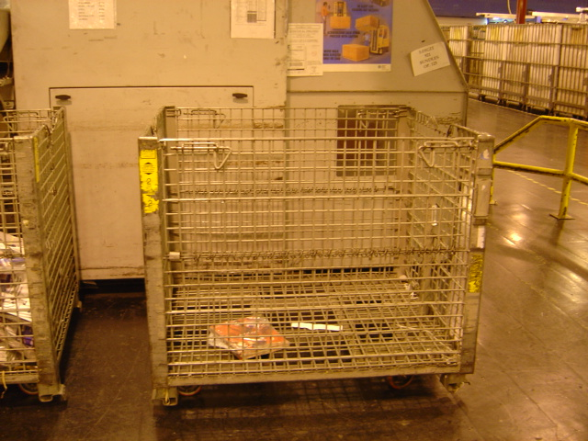  WIRE CONTAINER  320 lbs  Max loaded weight 2,000 lbs  NOTE: Maximum weight equals tare (equipment) + contents (mail) | 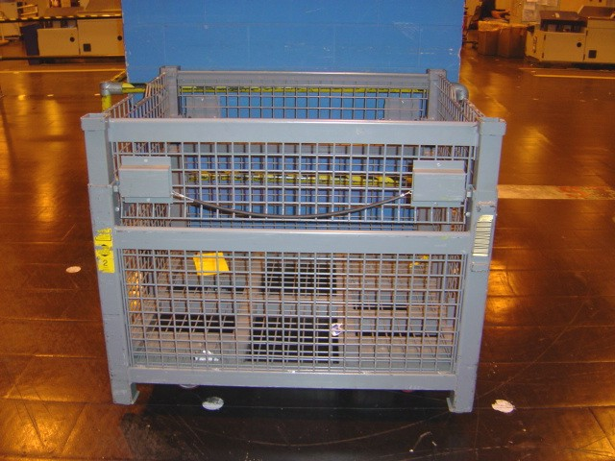  COLLAPSIBLE WIRE CONTAINER  380 lbs  Max loaded weight 2,000 lbs | 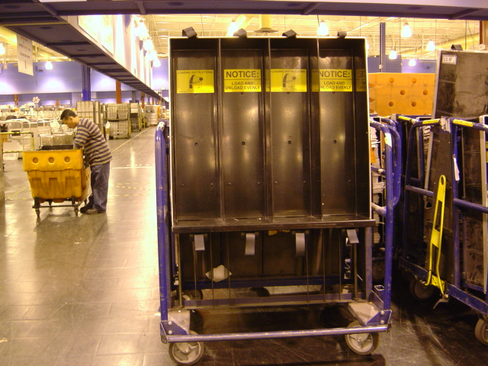  FLAT MAIL CART  “ERGO CART”  404 lbs  Max loaded weight 1,500 lbs
NOTE: Maximum weight equals tare (equipment) + contents (mail)

